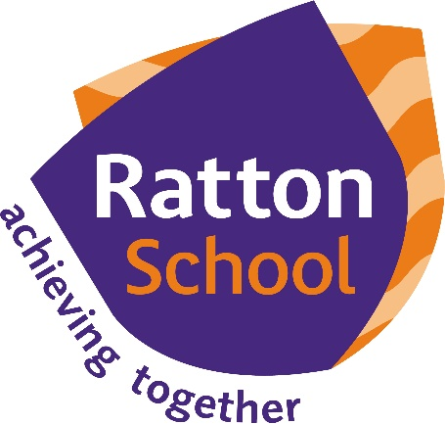

STUDENT WORKBOOK
The function of educations is to teach one to think intensively and to think critically. Intelligence plus character -that is the true goal of education.
Martin Luther King, Jr

Name
Subject | Transition Workbook
Teacher
Group
Tutor Group
- You should be proud of your book
- Please care for this book. Each page is an indicator of your attitude, your effort, industry and determination
- Keep your book clean and graffiti free
- Respond to your teacher’s marking; this will create progress
- Your book is your responsibility. If you lose or deface your book, you will be sold a new book at a cost of 50p

RATTON SCHOOL
- Compassion
- Creativity
- Teamwork
- Effort
- Responsibility
- Respect
HOW TO USE THIS BOOK

MARKING AGREEMENT

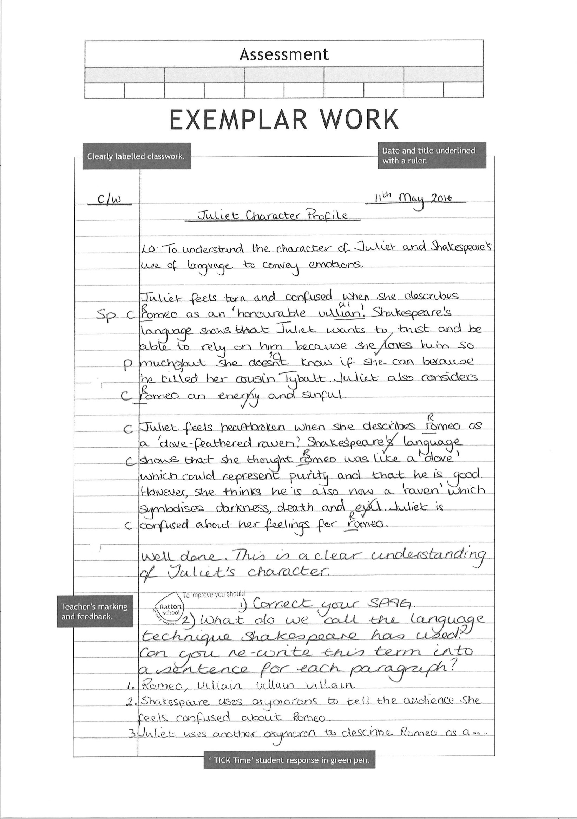

Science
Science
Science
English
English
English
Maths
Maths
Draw your own concentric circles with a compass
Maths
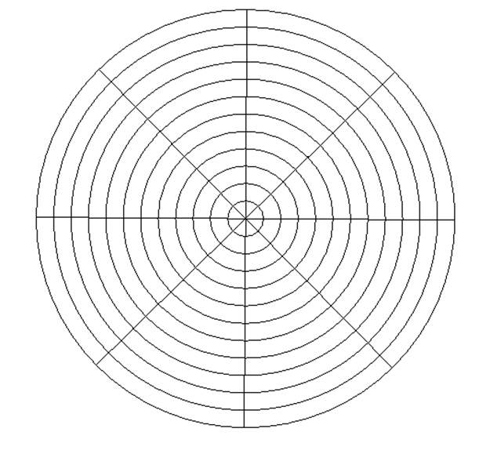
MFL
MFL
MFL

VOCABULARY
HOMOPHONES
WORDS THAT SOUND THE SAME

CONNECTIVES AND CONJUNCTIONS

MARKING AGREEMENT

PARTS OF A SENTENCE

PUNCTUATION

