Ratton Transition Tasks – these are aimed to provide a flavour of one or two topics and practices your son/daughter will be involved in within the Year 7 curriculum. Any work that is completed should be brought to the relevant teacher at the beginning of school in September.
Science tasks | Watch the Space Storybots video and answer the questions  (available at https://www.youtube.com/watch?v=Vb2ZXRh74WU)  Space Hero project – Research the work of a famous Scientist who has helped us to understand more about Space. There’s a PowerPoint to help you.  Challenge: Phases of the Moon – why does the Moon appear to change shape? Watch the animated song and answer the questions. You could also complete your own Moon diary – sketch how the shape changes over the month – can you add the correct names to the different shapes?

English tasks | Task: Write a story or description suggested by this scene:  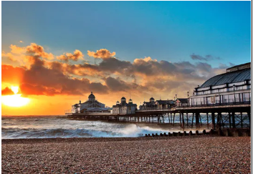  - Plan a story or description – no more than 300 words.  - Build a bank of ambitious vocabulary to use in your story or description. Think of some sophisticated words to describe the sea, clouds and sky.  - Write your story or description.  - Proofread, change and edit your story to improve it.

English tasks | Create an advert to entice tourists to visit Eastbourne.  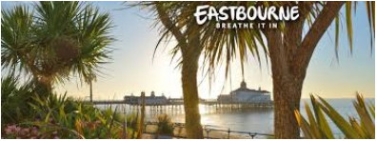  Include:  - A snappy heading and slogan  - Some images of Eastbourne’s attractions  - Some paragraphs persuading people to visit our town
 | Challenge: Write a review of your favourite book. Create a presentation to deliver to your class, persuading them to read this book.

Maths Tasks | Spiral Project – Look at the PowerPoint and work through the slides.  There are 3 tasks to complete. Some are creative patterns to make using the spiral ratios.
 | Challenge: Design spirals using other topics in Maths, thinking outside the box! Bring all work in school in September to enter the competition and receive Rewards.

MFL tasks  (covers all languages taught) | Research and write down the numbers 1-10 in all of the languages that are studied at Ratton School (French, German, Spanish, Mandarin).
 | Create a poster with the four flags of the languages we study and write “hello” in those languages on the flag for that country (e.g. French – “bonjour”).
Challenge: Watch this video and write down three reasons why you are interested to learn a foreign language at Ratton School:
https://www.youtube.com/watch?v=Uz4M0pE5tro

