FINDING OUT ABOUT RATTON SCHOOL
This booklet is to help you to think about moving on from your primary school to Ratton school. It has been designed by the Learning Support Department.
It can be both an exciting time and a time for many questions.
This booklet will help you feel more prepared to join us as a Year 7 student.

NAME: _________________________________________

CONTENTS
This booklet is aimed to be completed by you and a member of your family/ carer.
1 | VISUAL MAP OF RATTON SCHOOL | This is a photo map and shows the important places around the school. It will help you get familiar with the classrooms and corridors. | Pages  3-8
2 | WE’RE HERE TO HELP | These are some key staff that are always willing to help. It shows the Learning Support team and the Pastoral teams. | Pages  9-11
3 | UNDERSTANDING YOUR TIMETABLE | This section tells you about how the timetable is organised at Ratton. | Pages  12 & 13
4 | DIFFERENCES BETWEEN PRIMARY AND SECONADRY SCHOOL | This section discusses some of the key topics of Ratton –  - Making new friendships  - Getting to school  - Homework | Pages  14-17
5 | ‘MOVING ON UP’ BOARDGAME | This practical activity can be played with a parent/ carer and can help you talk about your feelings towards starting at Ratton. | Page  18

VISUAL MAP OF RATTON SCHOOL.
- Here is a photo map of the important places to know around Ratton school.
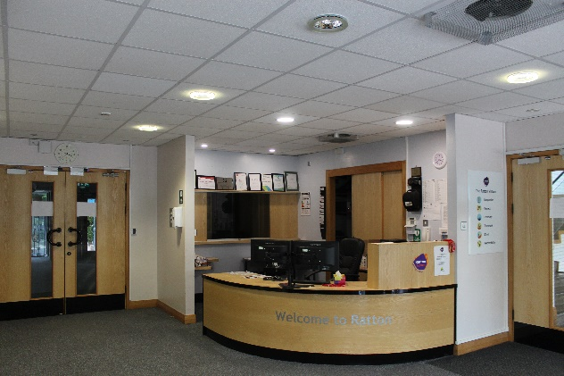  1  Start at Reception then through a door on your right you see… | 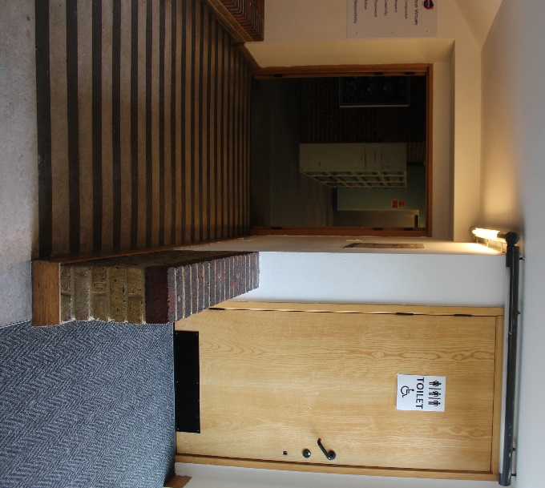  2  The Disabled / multi-gender toilet. Head down the slope to see…
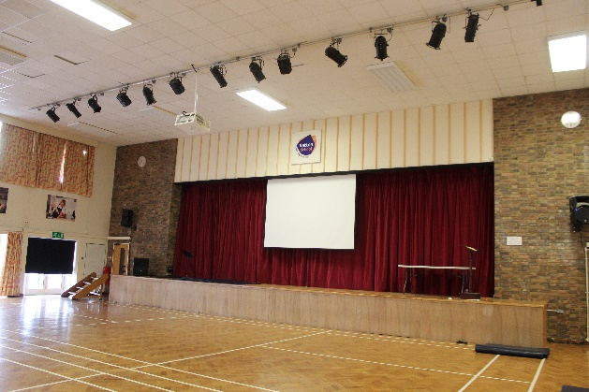  3  The Hall on your left and … | 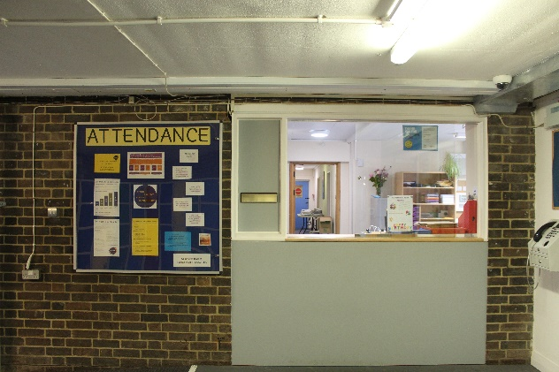  4  The General Office on your right. Here you give in forms and can sort out your locker.
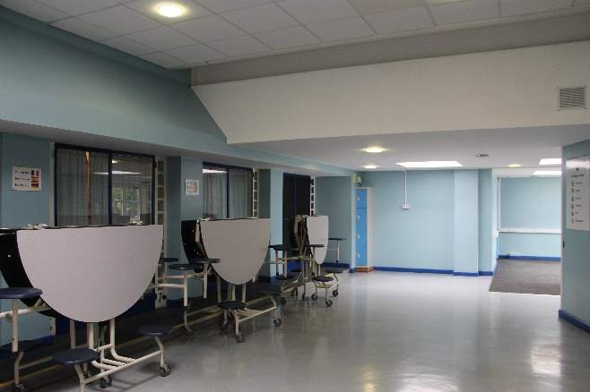  5  South Playground  We’re going down here  Next is the Blue Room. At lunchtimes, snacks are available here to purchase. | 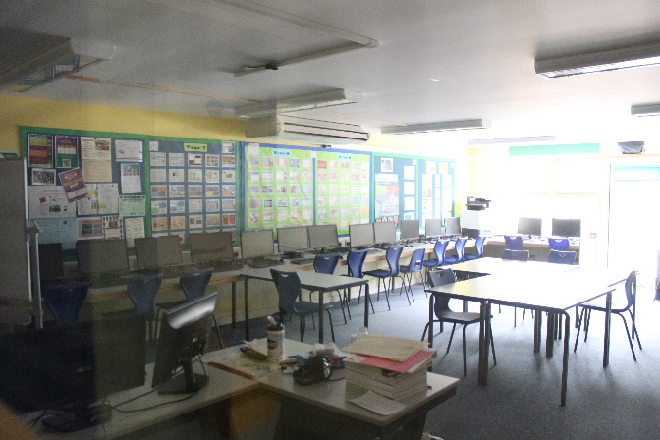  6  Down a corridor on your right we have IT classrooms on one side and …
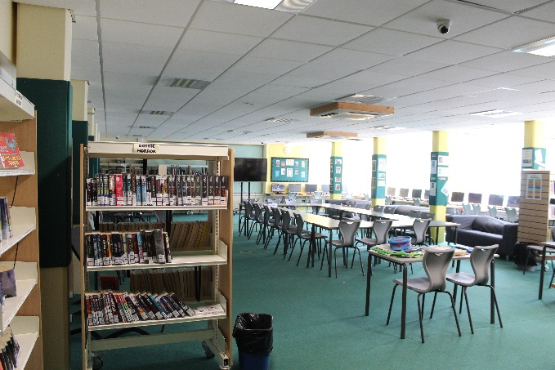  7  Learning Resource Centre (LRC) on the other. You will know this better as a Library.  English corridor | You can write down any questions you have here about the map-
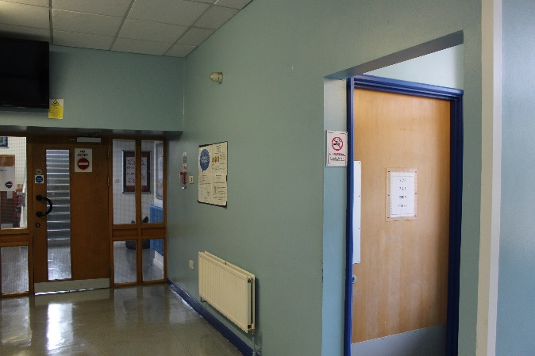
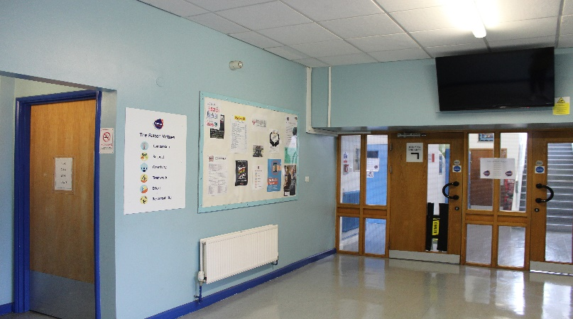
At the end of the corridor you get to the Year 7 & 8 Toilets.
8
Boys on the Left and Girls on the Right.
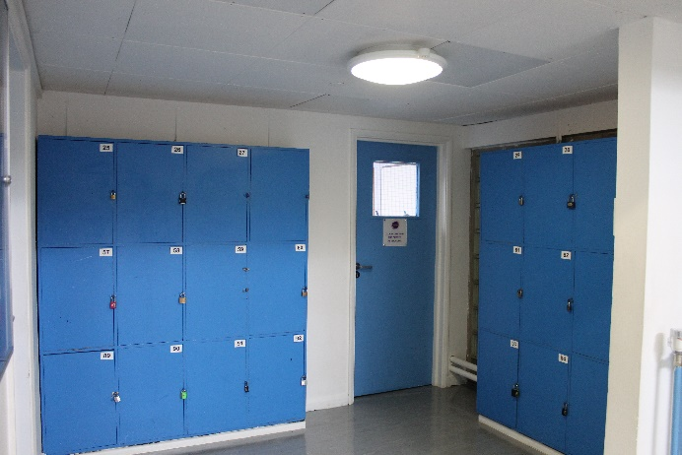  9  Through the doors tucked away on the right is the Globe HOC office. (Head of Community) | 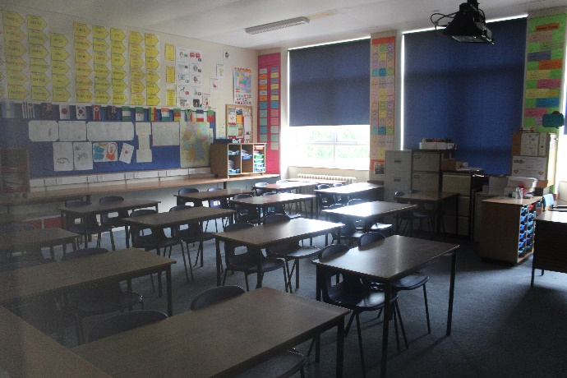  10  Along the corridor past all the English classrooms we get to MFL which stands for Modern Foreign Language (French, German, Spanish, Mandarin) .
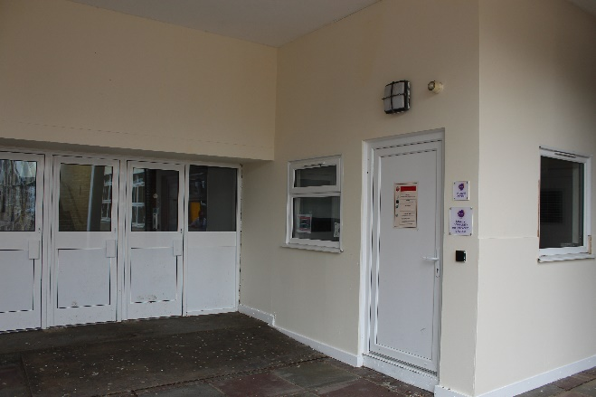  11  Before we head outside, here’s the Lyceum HOC (Head of Community) Office. | You can write down any questions you have here about the map-
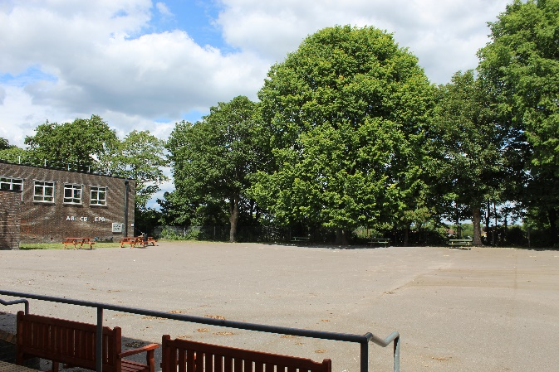  12  Here is a walk way between playgrounds  Which is on the South Playground (we have two playgrounds!) with the Boys PE changing rooms.  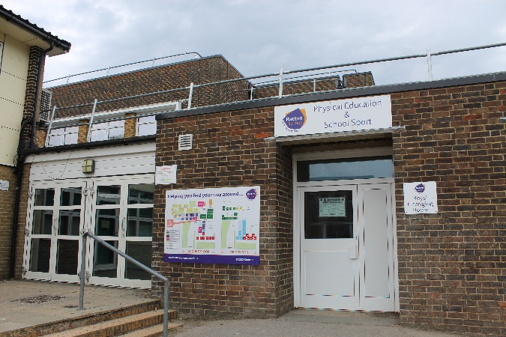 | 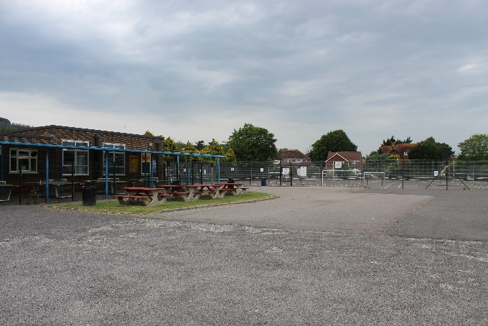  13  That links to the North Playground. Can you see the Table tennis and Tennis courts? The Girls PE Changing rooms are on this side.  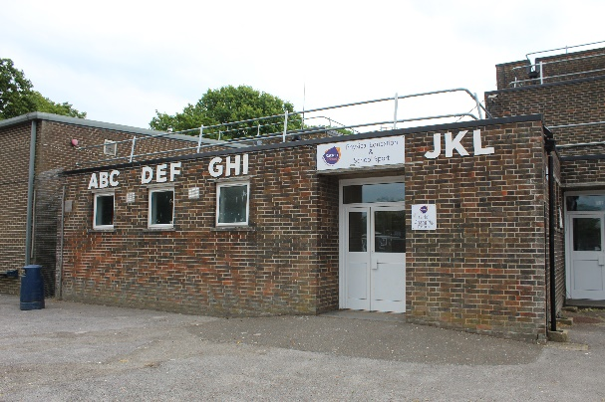
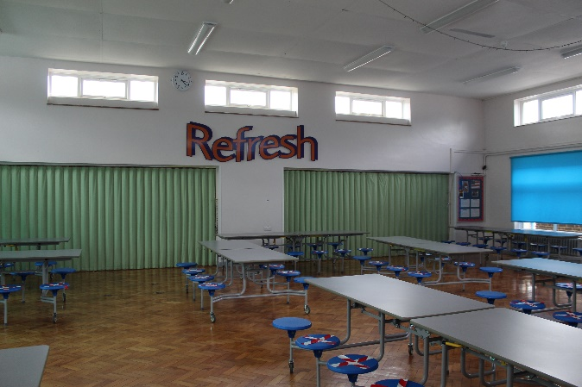  14  Back inside, we have Refresh. This is the name of our canteen, you can get different hot meals here every day. | 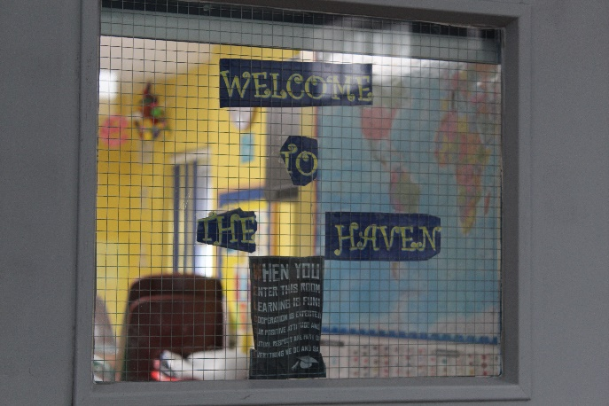  15  Inside Refresh is a quiet room to eat lunch called The Haven. This room has TAs in every lunchtime. The Haven is a place where small group sessions run (such as social skills groups).
16  Just outside Refresh is a machine you can add money onto your account to purchase your lunch. This can also be done by ParentPay. | 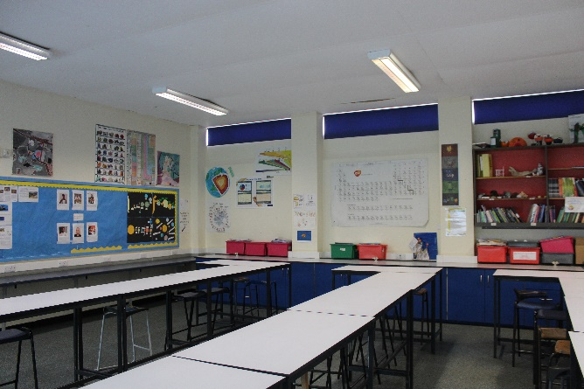  17  The next corridor leads to the Science classrooms. (Watch out for the bunsen burners!)
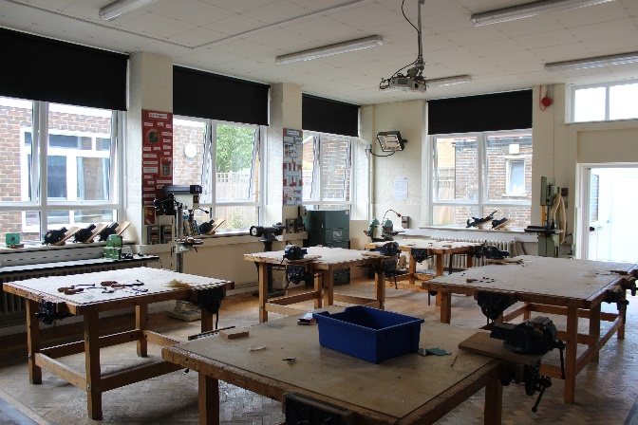  18  Also, along the Science corridor, you will find DT Classrooms. You will get to make all kinds of things including models and keyrings. | 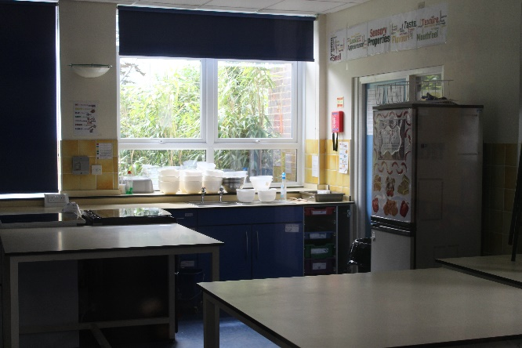  19  You will get to make edible dishes in the Food Technology classrooms.
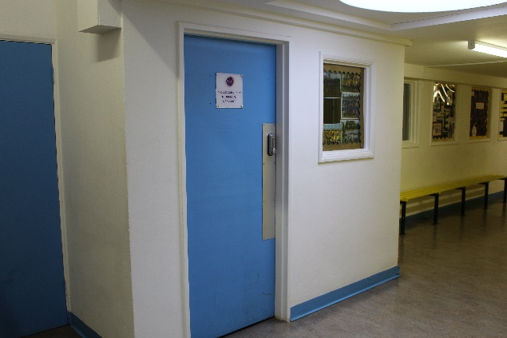  20  One food tech room up here  DT this way  This is where you will find the Apollo HOC (Head of Community) office. | 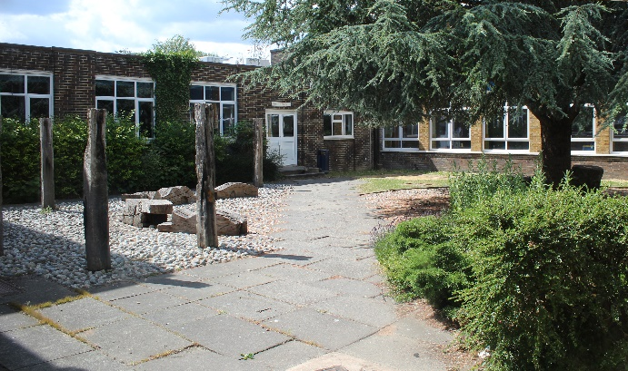  21  From here, if you go through the garden, you will be near …
Mr Brown’s office and a stairwell going up to Dance, Drama, and Music. It’s up here you will find the Lyric HOC Office. 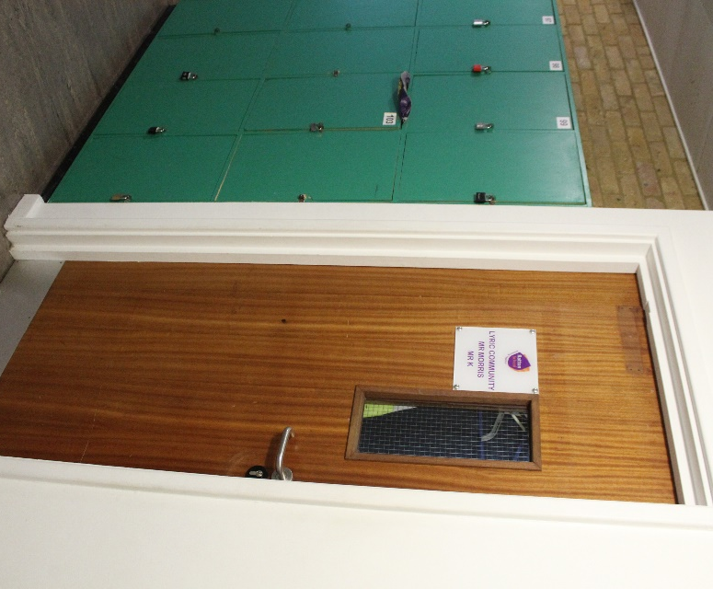  This way to Drama & Music  This leads to the Dance studio  22 | Back down stairs to the …
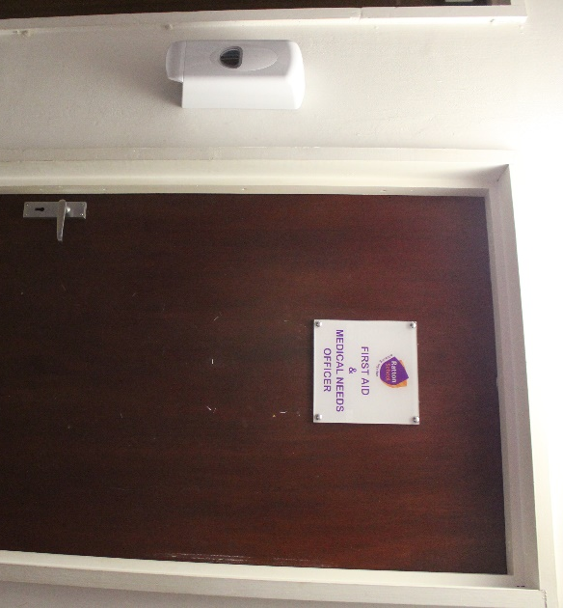  23  The Medical room. There is always a first aider on duty in here. If you feel unwell at school, you need to ask a teacher to send for them. | 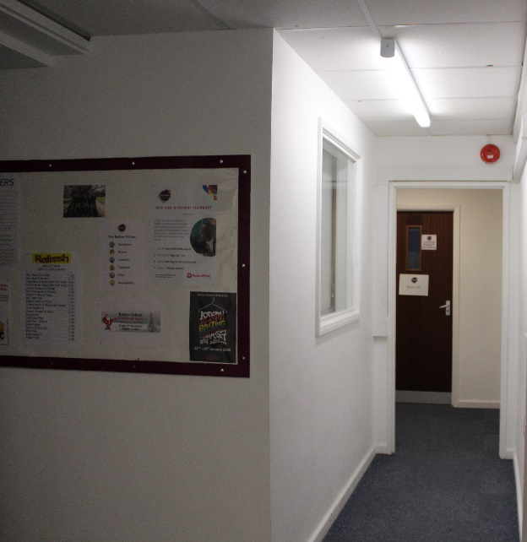  24  To the left is the Learning Support Department in room 125. There is always someone in here to help you.  26
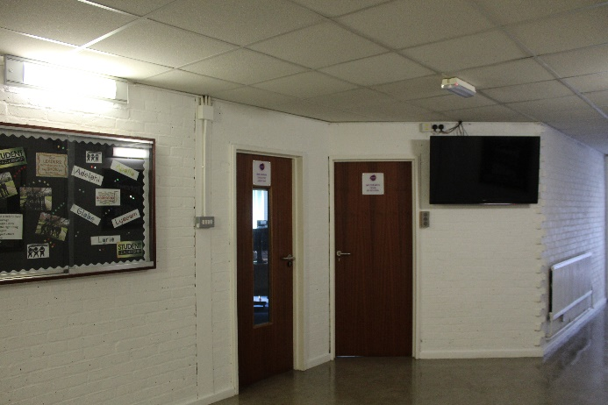  25  To DT & Science  To 125  Turning around you have the Head of School’s Office ,at the junction. | 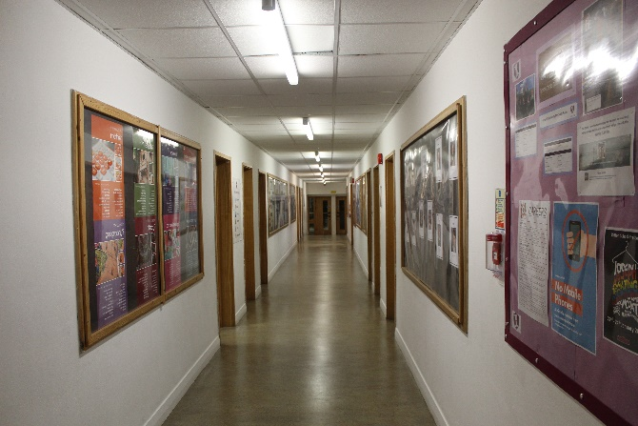  To the Hall  Backing away you will find yourself in the Maths corridor. The whole department really ADDs to the school.
277  Along the Maths corridor you will find the Adelphi HOC Office. | 28  The Student Hatch is where you can speak to the Reception.

We are all here to help!
- Key members of staff that are always willing to help you.
Mr Peevers  Head of school | Mr Brown  Senior Assistant Head – Inclusion and Induction
Learning Support Team
Mrs Veale  Welcome to our school. My name is Mrs Veale and I am the SENCO. I have worked at Ratton for eight years and enjoy supporting students and their families to get the best out of their education. I like swimming, cycling and running (I have completed a triathlon). If you have any questions about starting Ratton, please email me  mveale@ratton.co.uk | Mrs Wiegand  I am the Learning Support Administrator, based in room 125. I have worked at the school since March 2020 so am still learning my way around the school!  Likes: Growing fruits and vegetables  Dislikes: Slugs  Interesting fact: Once had a cat with three legs!
Mrs Weller  My name is Mrs Weller. I have worked at Ratton for eight years now. My favourite subjects are Maths and History. I like things to be neat and tidy, my planner is always immaculately colour coded. I have a dog named Wilf who is 15 years old that I love dearly. | Mrs Edwards  My name is Mrs Edwards. I am a teaching assistant and am part of the Learning Support Team. I am really looking forward to welcoming you at Ratton soon. History was the subject that I enjoyed most at school. I wonder what your favourite subject will be! I hope you’ll have fun finding out. The important thing to remember is that the Learning Support Team will be there to help you. Stay safe, enjoy the summer holidays and see you soon.
Mrs Elterafi  I have been at Ratton for 5 years and my expertise is working with students with EAL.  I really enjoy cooking. My colleagues love it when I bring in some of my dishes and share my recipes. I also like travelling and exploring different places and cultures. I don’t like the winter, it’s so cold for me. | Mr Gooch  My name is Mr Gooch and I have been at Ratton school for just over a year.  I like most sports, especially football, and my favourite team is Liverpool.  I don’t like doing DIY around the house because I am not very good at it.  My favourite subject is maths, I love Maths.
Mrs Hari-Johnston  I have been here at Ratton for about a year now. I enjoy reading, staying active and getting creative. I dislike raisins. I would describe myself as compassionate and understanding. I used to have a blue hair, which is an interesting fact about me. Perhaps you could ask me about it? | Miss Taylor  I have been at Ratton for 4 years and have experience of supporting students in lots of ways. I am the Duke of Edinburgh manager which is an award you can do when you’re 14.  My passion is for anything creative, art, crochet and baking.  If you see me around, feel free to come say “Hi”.
Miss Yeandle  I like chocolate, cake and all things sweet. I make sure I have a ‘chocolate a day’ in my lunch box!  I don’t like lots of ants. They once raided my bubblegum machine when I was 10 and left a trail all the way out of my bedroom window. Yuck!  I have been at Ratton for 5 years and my area of expertise is understanding Social, Emotional and Mental Health needs of our students. | Miss Lewis  I love plants and animals and being outside in the sunshine while spending time with my family and friends.  I have worked at Ratton for just over a year. My favourite subjects are Science and Maths. I am always excited when I can help explain anything to do with these lessons.
The Community Teams at Ratton.
The Heads of Community ensure the ethos of their community and good student progress.
Heads of Community  (HOC) | Assistant Head of Community  (AHOC)
Adelphi  Mrs Scott – Smith | Mrs Connor
Apollo  Mr Kingham | Mrs Jones
Globe  Mrs Grover | Mrs Huggins
Lyceum  Mrs Papagna | Mrs Cox
Lyric  Mr Morris | Mr K Morris
Ratton Timetable
All secondary schools have timetables which are great because you know what you will be doing every day. This is an example timetable at Ratton.
GOLD WEEK
GOLD | Monday | Tuesday | Wednesday | Thursday | Friday
Lesson 1 | HISTORY  Room 207 | DRAMA  Room 225 | ART  Room 223 | MATHS  Room 116 | ENGLISH  Room 204
Lesson 2 | ENGLISH  Room 204 | GEOGRAPHY  Room 101 | SCIENCE  Room 136 | HISTORY  Room 207 | SPANISH  Room 201
Lesson 3 | IT  Room 111 | PE  Room gym | ETHICS  Room 210 | SCIENCE  Room 136 | DANCE  Room 221
Lesson 4 | ENGLISH  Room 204 | HISTORY  Room 212 | MATHS  Room 116 | SPANISH  Room 201 | DT  Room 133
Lesson 5 | GEOGRAPHY  Room 209 | SCIENCE  Room 136 | MUSIC  Room 218 | ENGLISH  Room 204 | MATHS  Room 116

BLUE WEEK
BLUE | Monday | Tuesday | Wednesday | Thursday | Friday
Lesson 1 | ENGLISH  Room 204 | DANCE  Room 221 | MATHS  Room 116 | SCIENCE  Room 136 | PE  GYM
Lesson 2 | SCIENCE  Room 136 | DT  Room 133 | IT  Room 111 | DRAMA  Room 216 | ENGLISH  Room 204
Lesson 3 | DT  Room 133 | FOOD TECH  Room 131 | ENGLISH  Room 204 | MATHS  Room 116 | ART  Room 223
Lesson 4 | MATHS  Room 116 | MUSIC  Room 117 | HISTORY  Room 212 | GEOGRAPHY  Room 209 | SPANISH  Room 201
Lesson 5 | ETHICS  Room 210 | SPANISH  Room 201 | MATHS  Room 116 | IT  Room 111 | ENGLISH  Room 204

At Ratton the timetable runs over two weeks. These are divided by colours, Gold week and Blue week. When you have worked through all of Gold week and all of Blue week you go back to the beginning of Gold week.

What lesson is on BLUE Wednesday lesson 3? ………………………………………………………………..
In what room do Maths lessons take place in this timetable?................................
What days in a GOLD week is English on?........................................................
What lesson is on GOLD Monday lesson 1?.......................................................
When is Music on a BLUE Thursday?...............................................................

The School Day
When you start Ratton there will be 5 lessons each day. Here are the timings for the school day.
Tutor time | 8.40am – 9.05am
Lesson 1 | 9.05am – 10.05am
Time to move | 10.05am-10.10am
Lesson 2 | 10.10am – 11.10am
First Lunch | 11.10am – 11.40am
Lesson 3 | 11.40am- 12.40pm
Lesson 4 | 12.40pm -1.40pm
Second Lunch | 1.40pm – 2.15pm
Lesson 5 | 2.15pm – 3.15pm

- What time does lesson 2 begin?.............................................

- What time is the first lunch? …………………………………………………………….

- How many lunch breaks are there in one day?..........................

- How long are the lessons?..................................................

- When is Tutor time? ……………………………………………………………………….
Write down any other questions you want to ask about the timetable at Ratton school-

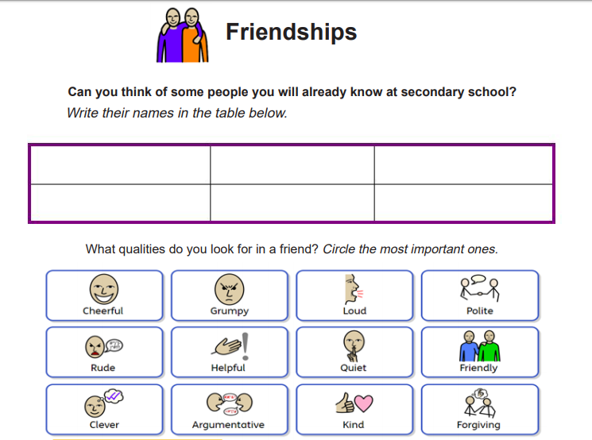
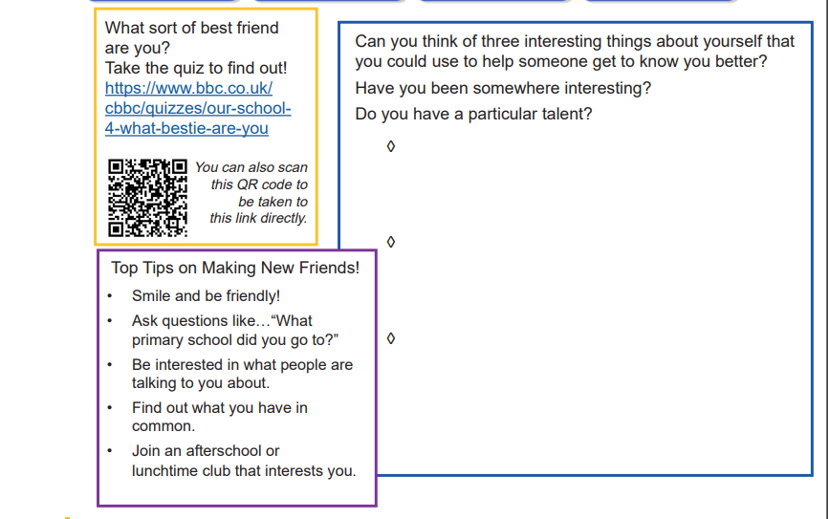
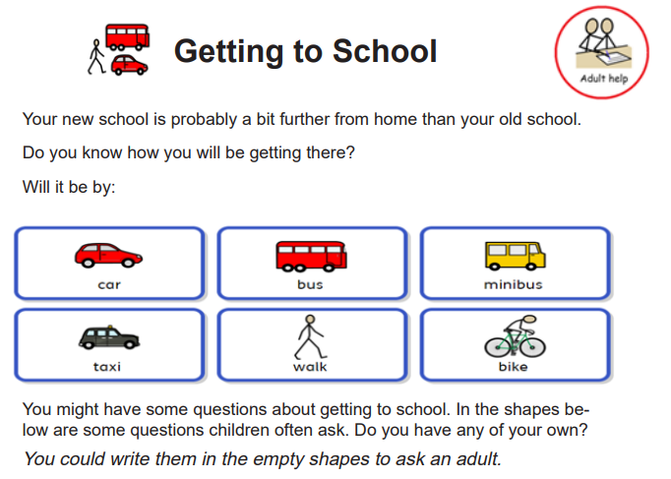
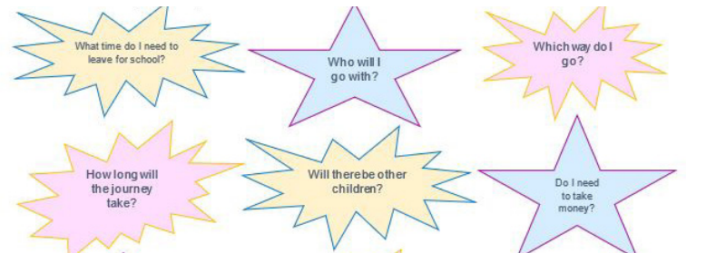
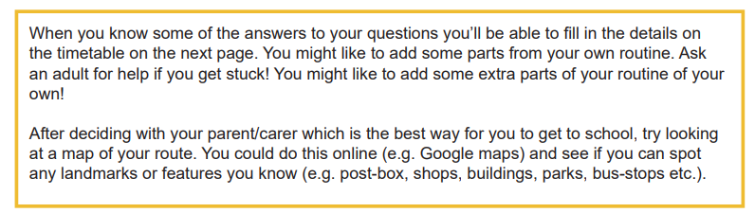

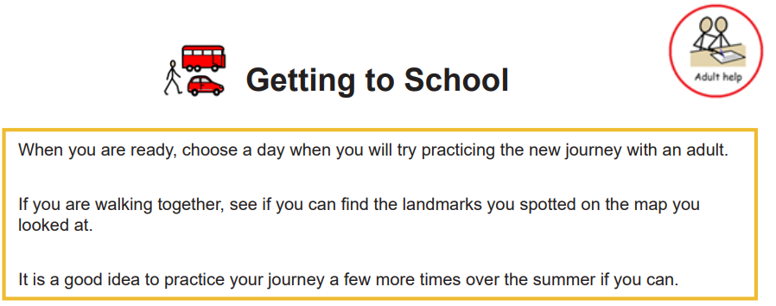
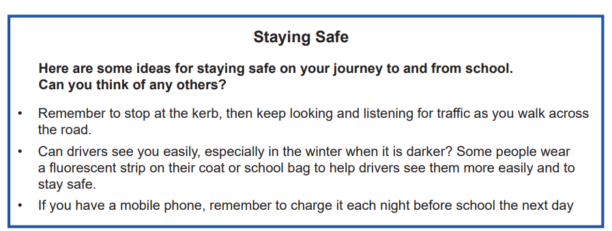
- Making your own way to and from school
I will travel by ______________________________ (Car, Bus, Train, Walk, Other)

I will need to leave home about ______________________________________

If I miss my bus or train I could __________________________________________
Coming home
I will travel by ________________________________ (Car, Bus, Train, Walk, Other)

I will need to leave school about _____________________________________

If I miss my bus or train I could __________________________________________

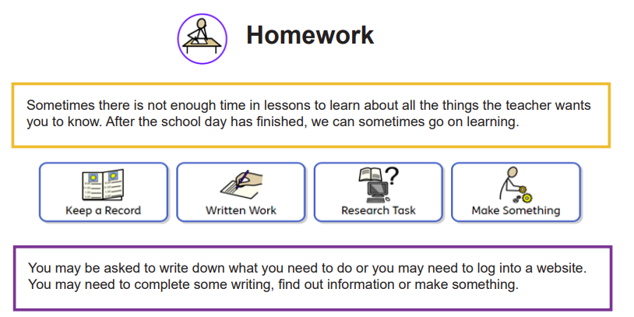
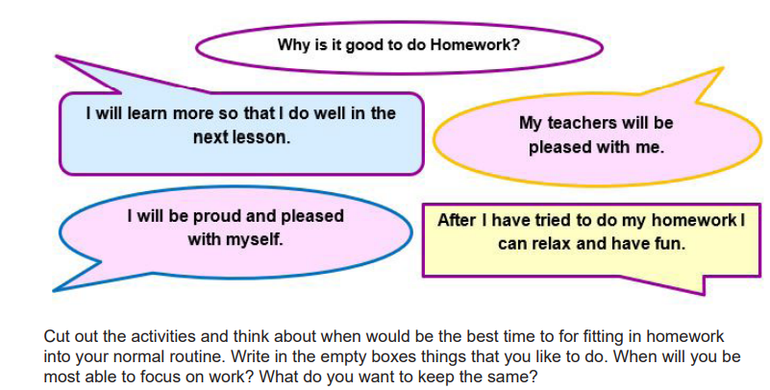
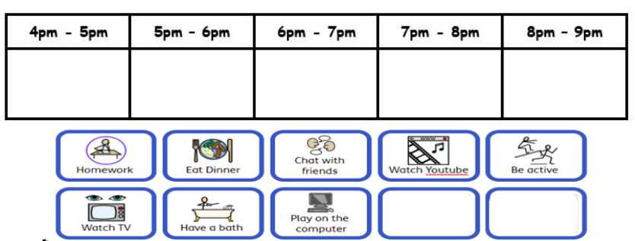
- Have a go at this ‘moving on up’ board game. It may help you to prepare for starting at Ratton school.
