

Parents’/Carers’ Handbook

2020 - 2021

A copy of this document can be found electronically at:

<http://www.ratton.co.uk/starting-ratton>

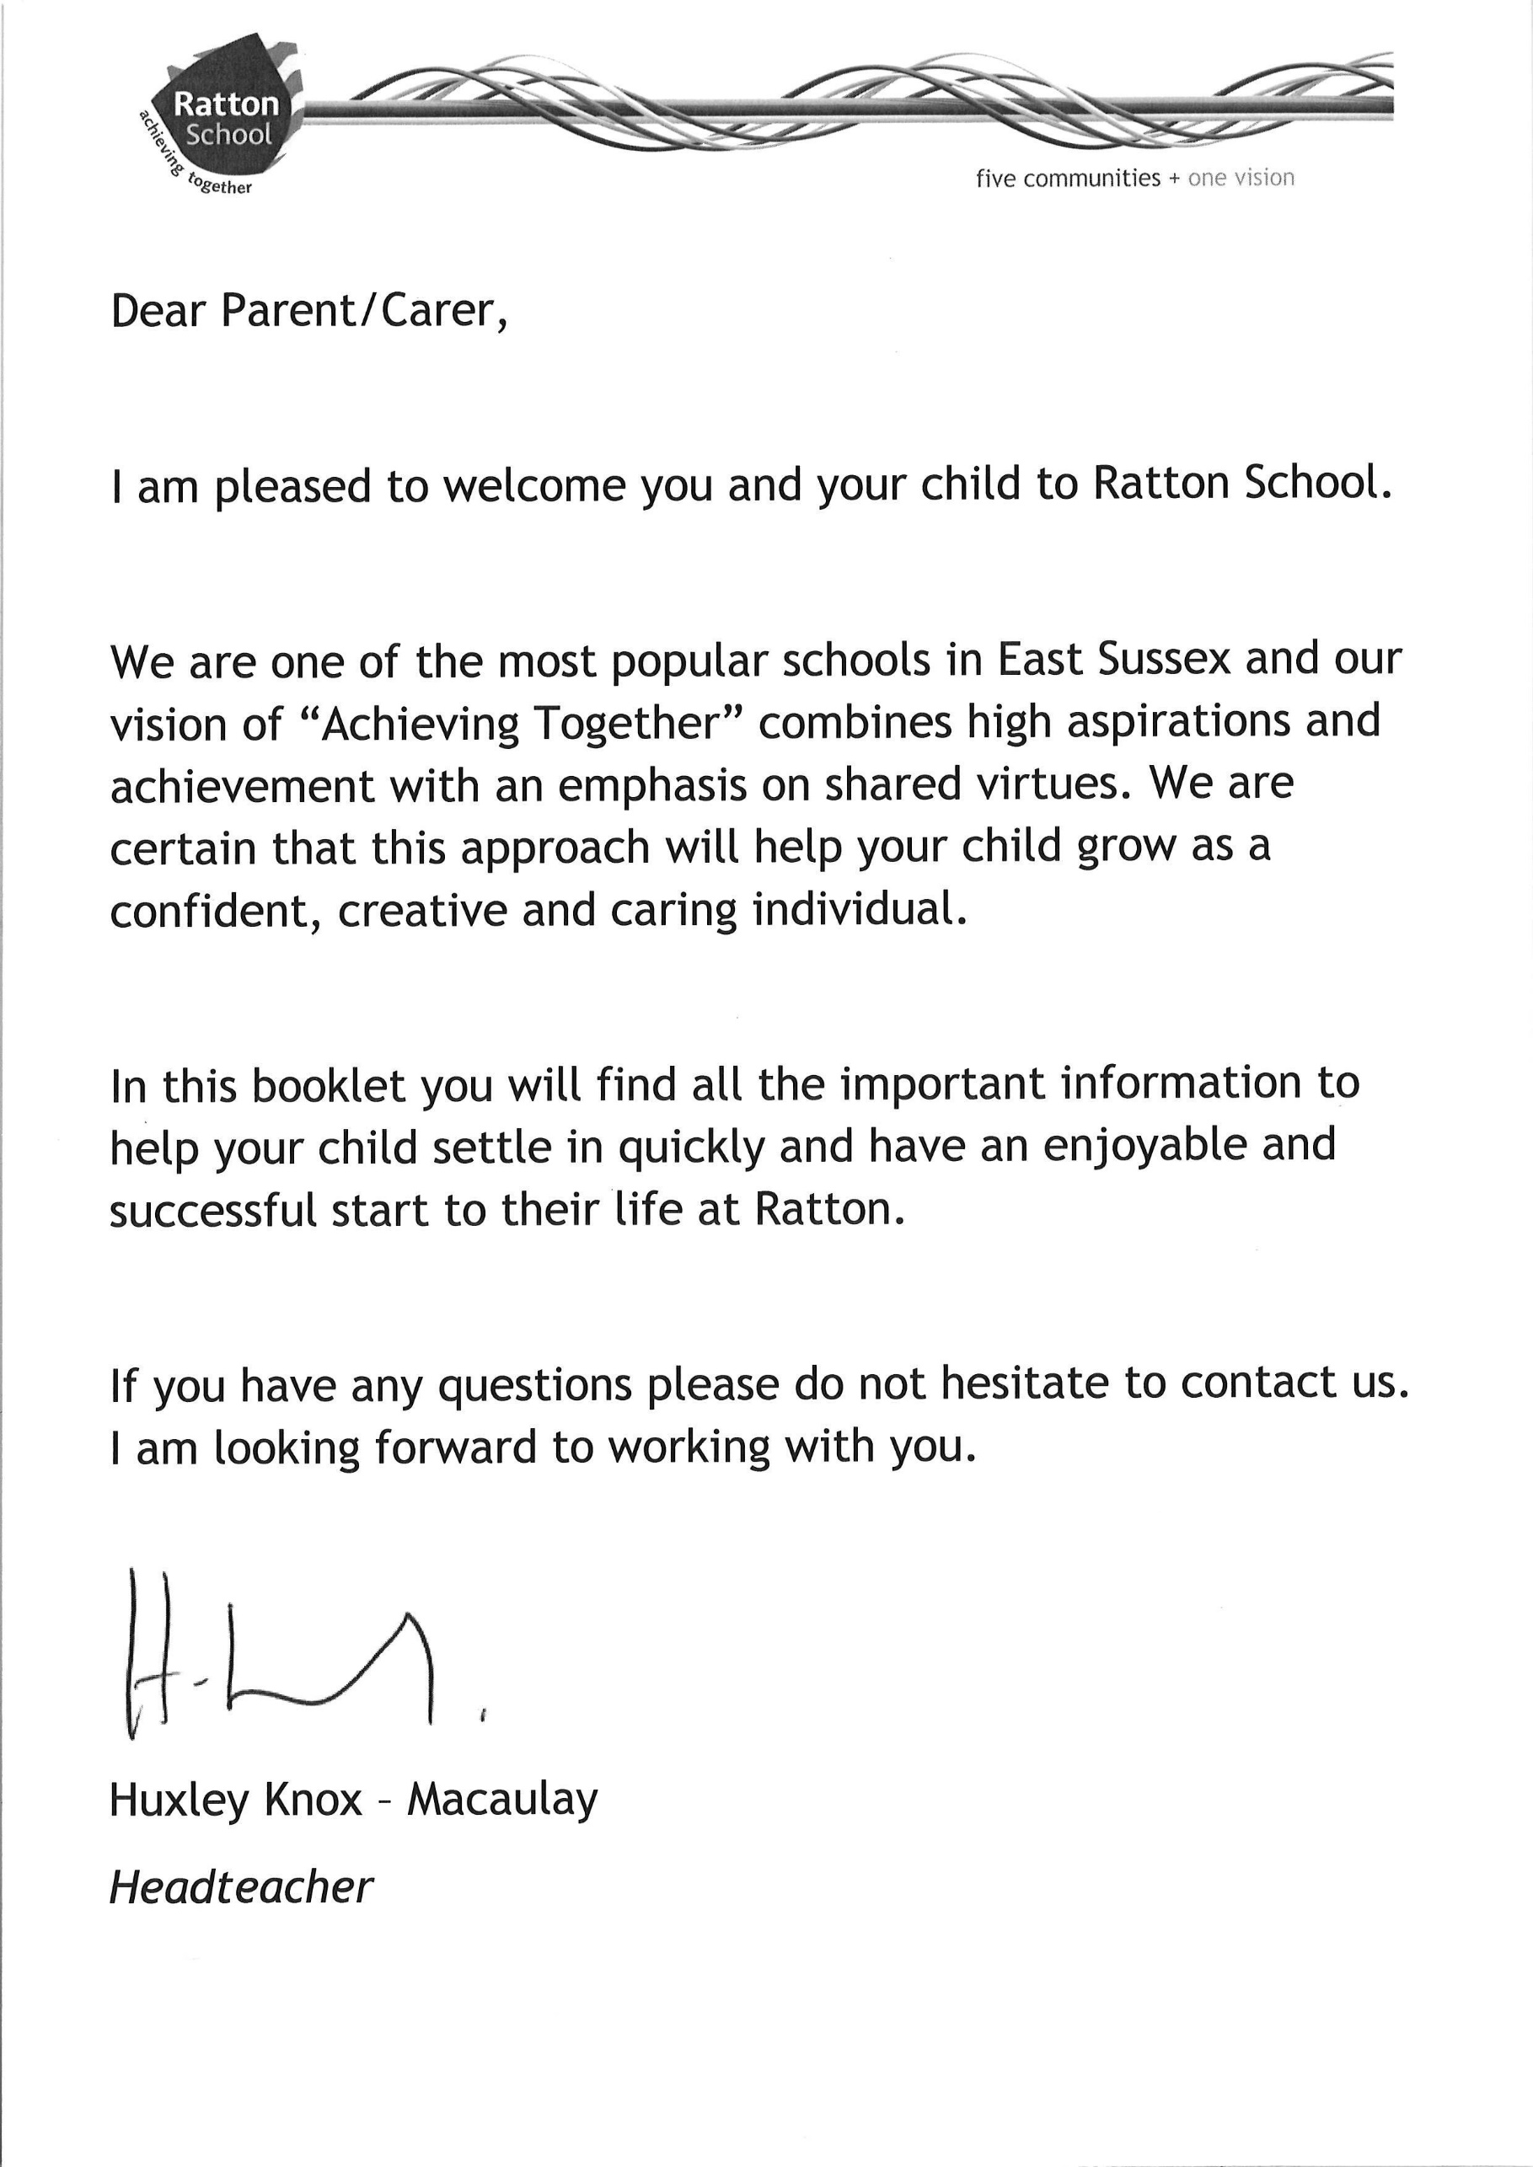

*Executive Headteacher*

Contents

|  |  |  |
| --- | --- | --- |
| Letter from Headteacher | ……………………………………………………….. | 3 |
| Contents | ……………………………………………………….. | 4 |
| The Ratton Virtues | ……………………………………………………….. | 5 |
| Introduction | ……………………………………………………….. | 6 |
| The Curriculum | ……………………………………………………….. | 7 |
| Your questions answered | ……………………………………………………….. | 8-16 |
| Uniform | ……………………………………………………….. | 8 |
| School Practice and Policy | ……………………………………………………….. | 9 |
| Participation | ……………………………………………………….. | 9-10 |
| Homework | ……………………………………………………….. | 10 |
| Behaviour | ……………………………………………………….. | 11 |
| Basics | ……………………………………………………….. | 11 |
| Behaviour in the classroom | ……………………………………………………….. | 11 |
| Diploma | ……………………………………………………….. | 11 |
| Attendance and punctuality | ……………………………………………………….. | 11-12 |
| Medical issues | ……………………………………………………….. | 12-13 |
| Communication | ……………………………………………………….. | 13 |
| Learning Communities | ……………………………………………………….. | 14 |
| Food | ……………………………………………………….. | 14-17 |
| Ratton School Timetable | ……………………………………………………….. | 17 |
| Ratton School Governors | ……………………………………………………….. | 18 |
| Cycling to school agreement | ……………………………………………………….. | 19 |
| Student code of conduct for ICT | ……………………………………………………….. | 20 |
| Useful addresses | ……………………………………………………….. | 21 |

**The Ratton Virtues**

Virtue can be understood as the good actions of people. When we live with virtue it builds good character and we become happier and more successful. We at Ratton want to nurture all our students to give them the skills and attitudes they will need throughout their lives. This is why we emphasise 6 virtues that will help students build good character.

We aim to nurture Ratton virtues in all our students so these virtues will be linked to conduct points. Students and parents will receive a record of all the students’ achievement points and behaviour points as part of the student’s report.

**Compassion**

Ratton students show kindness and care for other people and their environment. Students will be rewarded for showing this compassion. This may include showing concern for other people, raising money for our charities or putting rubbish into the recycling bins

**Respect**

Ratton students act with respect to others both in and out of school. We value diversity and avoid discriminatory language. Students will be rewarded when they speak and act in a respectful way. This may include being polite to others, demonstrating a positive attitude and speaking out when others use discriminatory language.

**Creativity**

Ratton students are curious about the world around them. They are encouraged to think creatively and ask thoughtful questions. They express themselves articulately and are good problem solvers. Students will be rewarded when they ask good questions or when they express their own ideas well. We will also reward those who can find solutions to problems and

work independently.

**Teamwork**

Ratton students know the importance of working as part of a team. They understand that we all have to do our fair share and get along with different people. Students will be rewarded when they demonstrate that they can work hard to ensure team success. We will also reward those who participate in teams in extracurricular activities such as music, dance, sport or enterprise projects.

**Effort**

Ratton students know that to be successful takes effort and resilience. Students are expected to put effort into all their endeavours, whether it is class work, homework or extra curricula commitments. Students will be rewarded when they put effort into lessons; especially when they show resilience and keep trying even when the task is a challenge.

**Responsibility**

Ratton students act responsibly by making sure that they are in the right place, at the right time, doing the right thing. They take responsibility for ensuring they have the right equipment, complete homework to a good standard and have a good attitude every lesson. Students will be rewarded for consistently demonstrating that they are ready to learn

**Introduction**

Our students have different needs, aspirations and abilities, and we must recognise and meet this challenge. Our aim is to give every student an education that is second to none.

We aim to do this by providing:

* A rich and varied curriculum relevant to future needs in adult life.
* Careful and consistent monitoring of each child’s progress.
* Regular detailed reports to parents and frequent opportunities to meet with us.
* Clearly enforced rules, including the major issues of behaviour, uniform, punctuality and homework.
* A wide range of excellent educational and sporting facilities.
* Established links with local business and industry, the careers service and local colleges.

**The Curriculum**

Students follow courses in Maths, English, Science, History, Ethics, Geography, Ethics (RE and PSHE), Physical Education, ICT, Resistant Materials, Food and Nutrition, Art, Art Textiles, Music, Drama and Dance. In addition, most students study one language – French, German, Spanish or Mandarin. In Maths, English and Science students are grouped according to their ability but in most other subjects they are taught in mixed ability groups.

Please note that the curriculum at Ratton is continually under review.

**Performing Arts**

There will be many opportunities to become involved in Performing Arts events and activities. We believe that Performing Arts enables students to develop into confident, caring and creative individuals who embody the school’s virtues.

**Religious Studies and Personal, Social and Health Education (PSHE)**

Religious Studies is a statutory subject for all students in British schools. At Ratton we teach it as part of the Ethics curriculum and students study the 6 major world faiths across Key Stages. They also reflect on spiritual, moral, social and cultural issues from a non-religious point of view. Students are encouraged to think for themselves and be respectful of others. At KS4 all students study Ethics as part of their core curriculum.

PSHE equips children and young people with knowledge, understanding, attitudes and practical skills to live healthy, safe, productive, fulfilled, responsible lives. At Ratton it is taught as part of Ethics, which all students study. One aspect of PSHE is Relationships and Sex Education (RSE). RSE plays a vital part in meeting schools’ safeguarding obligations. Ofsted is clear that schools should have a preventative programme that enables pupils to learn about safety and risks in relationships. Children and young people want to be prepared for the physical and emotional changes they undergo at puberty, and young people want to learn about relationships. RSE at Ratton is overseen by a subject expert who ensures all the resources are age appropriate and locally relevant to the students.

Ethics is a combination of PSHE and Religious Education. Both of these at Ratton are an integral part of our student curriculum. Ethics is taught by a specialist team who are aware of the importance good quality PSHE and Religious Education play in young people's development. Education in British values is woven throughout the Ethics curriculum as well as being taught across the wider school curriculum.

**YOUR QUESTIONS ANSWERED**

**UNIFORM**

*Q. Does my child have to wear school uniform?*

A. Yes. We will operate a strictly enforced policy on uniform.

Our uniform consists of:

* Ratton School Black Trousers (for boys and girls, available only from Ratton School website)
* Ratton School White Polo Shirt
* Ratton School Sweatshirt (which must be worn for all formal occasions, e.g. assembly)
* Black School Shoes (without any markings)

Students who come to school with incorrect uniform for any reason will be given an alternative from our stock for that day and parents may be contacted. The student will also receive a Basics detention on that day.

No facial (or rest of body) piercings are allowed and only one very small earring is allowed in each ear. Students with large earrings or extra jewellery will have these items confiscated and kept in the school safe.

These items may be collected by students, from the Community Office, at the end of the day. Repeated offences will mean these items may only be reclaimed by parents attending the school in person between 8.30am and 4.15pm during term time. All students should carry a school bag large enough to carry A4 sized books. Smaller bags are not appropriate.

Students should note that any refusal to wear the school uniform or to hand over offending jewellery may lead to Internal Exclusion or being sent home to change as the first priority.

*Q. What about difference in style?*

A. Whilst minor differences of style are inevitable, extreme versions of style, hairstyle, hair colour, fashion or excessive make up are not acceptable. We reserve the right to forbid items of dress which might be dangerous, such as jewellery or very high or narrow-heeled shoes.

*Q. Where can I obtain the school uniform?*

A. School sweatshirts may only be purchased directly from the school suppliers, Blueprint Leisure, and carry the school logo/community name. Other elements of the school uniform including school trousers must also be purchased through the school website.

All items of clothing, including P.E. kit must be clearly marked with the student’s name. Name tags can be purchased at most school stockists and supermarkets.

*Q. Where can students leave valuables whilst doing P.E.?*

A. Parents and students should be aware that the P.E. Department takes no responsibility for money, jewellery or watches, which must be removed during sporting activities. All such items should be left in personal lockers prior to the P.E. lesson.

**SCHOOL PRACTICE AND POLICY**

*Q. What is Ratton’s Policy on setting students according to their ability?*

A. Certain subjects group students according to their ability. Wherever this happens, the following principles are observed: progress is regularly reviewed and, should the teacher judge that it is appropriate; a student is able to move easily from one set to another. You will be informed in writing about any changes that are made to your child’s grouping. Setting will be primarily based on teacher assessment.

*Q. What does my child do if he/she loses or finds some property?*

A. Lost property is kept in the General Office. Students should ask if any property has been handed in. If any property is found, please hand this in to the General Office also.

**PLEASE ENSURE ALL ITEMS OF YOUR CHILD’S PROPERTY ARE CLEARLY**

**MARKED WITH HIS/HER NAME TO ENABLE THEIR RETURN IF LOST.**

If your child rings home for you to bring something in, it may be left at Reception but your child MUST come to collect it. We cannot be responsible for delivering items to students during the day.

Lockers are available for students in Years 7-11 at a non-refundable cost of £2.50 for the five years. This will be collected by the Finance Office. From Year 8, students will have to supply their own padlock and can share with one other student.

The school cannot be held liable for property lost or stolen from school. It is important, therefore, that large sums of money or valuable articles are not brought to school.

*Q. Can my child cycle to school?*

A. Yes, students may cycle to school. If cycles are brought into school they can be stored in the school bike racks and must be carefully maintained, roadworthy and locked when on school premises. Please note that bicycles are left at the school at your own risk. The bicycles are subject to inspection by the Police. Students should wear safety helmets.

*Q. Is my child allowed a mobile phone*

A. Your son/daughter can bring their phone to school but it is their responsibility and we accept no liability for loss or damage. Students cannot have mobile phones visible within the premises or during lesson time. If so, they will be confiscated until the end of the school day.

**PARTICIPATION**

*Q What happens on the first day in September at Ratton School?*

A. On the first day, new students should arrive at school by 8.40am. They will attend an assembly initially followed by time with their Form Tutor before normal lessons begin. Initially your child must bring a pen, pencil and ruler (PPR); other items such as a calculator, mini whiteboard pen, crayons, protractors, compasses etc. will also be useful additions.

*Q. Will my child be given opportunities to be included in all aspects of school life?*

A. Yes. The inclusion of all students, whatever their individual needs, is a special priority. There are many opportunities for students of all abilities and interests to participate to the full in all aspects of life at Ratton.

*Q. Can my child contribute to the care of the school and its environment?*

A. Definitely. Students are encouraged to feel that this is their school and the wide range of leadership opportunities and clubs are an important part of the process of involving them in the decisions the school makes. There is comprehensive information available on the school website on both the leadership opportunities available and the clubs on offer.

**HOMEWORK**

*Q. Will my child be given homework?*

A. Yes. Regular work outside lessons is an integral part of a child’s study. A timetable for homework will be provided for each student at the beginning of the year. We anticipate you will encourage your child to spend the appropriate amount of time on homework and will provide a suitable place for such work. Whilst it is essential that your child does his/her work independently, we do hope you will take an interest in the work which is being done and will look at your child’s books to see the standard of work she/he is achieving.

*Q. How long should homework take?*

A. In Year 7 the time spent on homework should average between thirty minutes to one hour per evening. This will increase as the students go through school until in Year 11 students should be studying between one to one and half hours each evening. Homework requirements will be published on the website.

*Q. Is there any way I can find out if homework has been set?*

A. Homework will be set regularly and students should record it in their diary. Details for each subject are published in advance on the website.

A staffed Homework Club runs every day from 3.15pm to 4.15pm and all students are welcome to attend.

**BEHAVIOUR**

*Q. What about school discipline?*

A. The School Code of Conduct has been discussed and planned by all levels of the school including students and is based on our expectations that members of our school will adhere to the school’s values. All students are encouraged to develop self-discipline in their behaviour and their studies. Staff, students and parents work together for the benefit of all to ensure that all are treated fairly. Encouragement and support are preferred to punishment and exclusion.

*Q. What standards of behaviour are expected in the street and on the buses?*

A. We expect all students to behave sensibly and quietly on the way to and from school. Even one or two students misbehaving can give a very bad impression to the public and create problems. Students representing the school during these times can expect school sanctions for misbehaviour. We know that parents will impress on their children the need for exemplary behaviour.

*Q. What rewards are available?*

A. We are very keen to reward outstanding effort or achievement both in and out of the classroom. Rewards are given for good work, homework, behaviour, attendance and punctuality. Rewards are entered onto a student’s record straight away. We celebrate achievements throughout the year and at a special event at the Winter Garden.

**BASICS**

* Punctuality (to school and lessons)
* Pen, Pencil, Ruler, School Diary (PPRD) possession of the above to each lesson
* Correct and correctly worn uniform

Students who do not conform to the above will receive a Basics detention that day during second lunch.

**BEHAVIOUR IN THE CLASSROOM**

If students exhibit inappropriate behaviour in a classroom they will be challenged in the following way:

**Stop:** Students will be clearly informed of their inappropriate behaviour and given a chance to change it.

**Choices Card:** Students who do not modify their behaviour will be given a choices card as a visual reminder of the choices to be made.

**Warning:** Students will receive a personal detention

**Relocation:** Students who do not modify their behaviour will be relocated to an alternative learning environment.

**DIPLOMA**

Students in Years 7 to 9 complete Diploma tasks three times per year. By completing the tasks students can achieve a Bronze, Silver or Gold award.

**ATTENDANCE AND PUNCTUALITY**

*Q. What should I do if my child is going to be absent from school?*

A. It is the duty of the parents/carers to contact the school as early as possible but always by 9.05 am, on the first and subsequent days of absence. You should notify us of your child’s name, tutor group, reason for absence and contact number. A short note should follow this, to the Form Tutor, on your child’s return.

*Q. What should my child do if he/she is late for school?*

A. Tutor group registration starts at 8.45 am. If your child arrives after the beginning of Period 1 then she/he is late and MUST report to Reception, where the late book must be signed. It is most important that staff at school know who is on the premises, especially in the event of an emergency.

**FAILURE TO REGISTER FOR MORNING OR AFTERNOON REGISTRATION WILL MEAN THAT A STUDENT WILL HAVE LEGALLY MISSED HALF A DAY’S EDUCATION**

Punctuality is very important. Daily ‘late gate’ is in place by Attendance Officers who record the names of students who arrive late.

Parents are asked to arrange all medical appointments outside school hours where possible. Lateness will result in a Basics detention and parents may be asked to attend a meeting with their Attendance Officer and Senior Assistant Headteacher in charge of attendance if this becomes persistent.

*Q. What should I do if I want to take my child on holiday during school time?*

A. In agreement with all Eastbourne secondary schools, Ratton School no longer routinely authorises any request for absence during term time, unless there are exceptional circumstances. Please remember that it is schools not parents who decide whether an absence is to be authorised. Request forms are available from the Attendance Office.

*Q. What happens if my child needs to leave school during school hours?*

A. If your child has an appointment between 8:45am and 3:15pm (i.e. doctor, dentist, hospital etc.), he/she should sign out from the School Reception when leaving the school premises, presenting the appointment card or letter at the same time and to their class teacher and form tutor in the morning. Upon returning, students should report back to the School Reception to sign in again. In this way, staff are aware at all times of students who should be on school premises.

**MEDICAL ISSUES**

*Q. What if my child is taken ill at school?*

A. If your child becomes ill whilst at school; first aid is available from a First Aider. In more serious cases parents are informed and, if necessary, an ambulance is summoned. If they are unwell during the school day they will be sent to the School Nurse, where a decision will be made as to the extent of the illness.

Your child must not contact you at home; they must speak to their class teacher during lessons or report to the Attendance Officer at lunch times if they are unwell.

*Q. How can parents assist the school in times of emergency or illness?*

A. Parents/carers are asked to make medical appointments outside of school hours. Communication between parents and staff is vital. You will be given a form to complete with details of your home address, workplace(s) and respective telephone numbers.

You will be asked to let us know any information relating to any disabilities, allergies or disorders that your child may have. This information is vital to the wellbeing of your child.

If your child has been prescribed any medication to be taken during school hours it must be handed into the General Office at the beginning of the day, as students are not permitted to carry medication on their person. The appropriate forms should be completed in advance in the ‘Forms to Complete and Return’ booklet.

If the personal details change, please inform the school as soon as possible. Due to the General Data Protection Regulation (2018) and the Data Protection Act (2018) should your child’s surname change we will need to see a copy of any documentation before we can change our records in school.

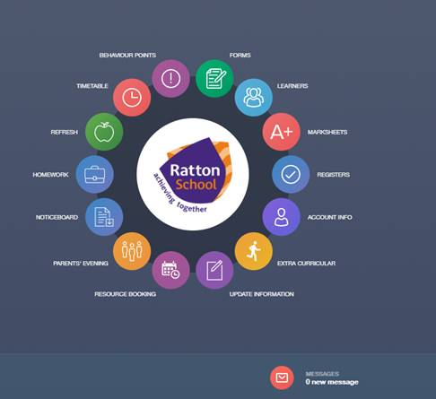There will be a section requiring two emergency telephone numbers – please ensure that you complete this in full to enable us to contact someone to collect a sick child, or to attend at hospital, if necessary.

**COMMUNICATION**

*Q. Will there be opportunities for parental consultations?*

A. Yes. On the New Intake Evening you will be asked to arrange an appointment to discuss your son’s or daughter’s progress with their Form Tutor. Each year you will have the opportunity to meet your son’s or daughter’s teachers at the Year 7 Subject Evening. If you have any particular concerns, please do not hesitate to contact the school at any time. Early in the year there will be a Success Evening which will also outline how we can best work together successfully.

*Q. Will there be regular reports?*

A. Yes, reports will be issued at regular intervals throughout each year, giving details of your child’s progress in all subjects.

*Q. What is the procedure for contacting Ratton School?*

A. Education involves the student, parents/carers and the school. We, therefore, encourage you to contact us if there are any problems or grievances. The Form Tutor, Attendance Officer or Care and Welfare Leader for your child’s community are the usual first contacts, but you can contact any of the staff listed below by telephone or e-mail. Urgent messages only, from relatives, will be given to students. We cannot guarantee messages will be relayed to your child for that day AFTER 2.00pm. We have a system called Edulink to facilitate home-school communication

|  |  |  |
| --- | --- | --- |
| Special Educational Needs Coordinator (SENCO) | Mrs. M. Veale | mveale@ratton.co.uk |
| Business Manager | Mrs T. Comfort | tcomfort@ratton.co.uk |
| Senior Assistant Headteacher – Attendance and behaviour | Mr I. Anderson | ianderson@ratton.co.uk |
| Senior Assistant Headteacher – Designated Safeguarding Lead (DSL) | Mr D. Brown | dbrown@ratton.co.uk |
| Senior Assistant Headteacher –  Training & Development | Mrs S. Bamford | sbamford@ratton.co.uk |
| Senior Assistant Headteacher – Teaching & Learning | Mrs. S. Byroo | sbyroo@ratton.co.uk |
| Senior Assistant Headteacher - Standards and ICT | Mr J. Chaundy | jchaundy@ratton.co.uk |
| Senior Assistant Headteacher - Curriculum | Mr J. Welsh | jwelsh@ratton.co.uk |
| Senior Assistant Headteacher - Pupil Premium | Mr M Hatton | mhatton@ratton.co.uk |
| Head of School | Mr G Peevers | efitzpatrick@ratton.co.uk |
| Executive Headteacher | Mr H. Knox-Macaulay | hknox-macaulay@ratton.co.uk |

LEARNING COMMUNITIES

|  |  |  |  |  |  |
| --- | --- | --- | --- | --- | --- |
|  | Adelphi | Apollo | Globe | Lyceum | Lyric |
| Head of Community (HoC) | Mrs C. Scott-Smith | Mr G. Kingham | Mrs N. Grover | Mrs. C. Papagna | Mr N. Morris |
| Assistant HoC | Mrs A. Connor | Mrs S. Jones | Mrs M. Huggins | Mrs K. Cox | Mr K. Morris |

We are all available and will do our best to see you in an emergency but we all have professional commitments and a telephone call for an appointment is necessary to ensure a meeting at a convenient time.

**FOOD**

*Q. Is there a canteen?*

A. Yes, the school operates a cafeteria lunch system. Students may choose from a wide variety of dishes and the charges vary accordingly. A balanced set meal is available at early and late lunchtimes for approximately £2.10 (£1.50 main 60p desert) at present, which includes a main course, two vegetables or salad and a sweet. Also provided is a choice of Dish of the Day (a complete meal in a dish), one of which is vegetarian. We implement a cashless catering student recognition system at Ratton School. We comply with the Data Protection Act and with the provisions of the Protection of Freedoms Act 2012 regarding the use of biometric data.

The Salad Bar is a healthy option giving a choice of salads, fresh fruit, cold sweets and hot and cold drinks. A Sandwich Bar provides a light lunch selling filled rolls, sandwiches, cakes and buns, made daily on the premises - these are on sale at both lunches.

*Q. Can my child take a packed lunch?*

A. Yes, students may bring a packed lunch - they will be expected to eat this in the blue room or outside.

*Q. What if my child is entitled to free school meals?*

A. Students who qualify for free school meals will be issued with a pass. This entitles them to food equal to the value of the set meal. Application forms are available in the Booklet of Forms, the school website and school reception.

*Q. What if my child suffers from an allergy or requires a special diet?*

A. You can contact [elemon@ratton.co.uk](mailto:elemon@ratton.co.uk) to discuss individual students.



**Your child may be able to eat in ‘Refresh’ for free!!**

Applications for Free School Meals are now being dealt with by East Sussex County Council.

Please contact them via their website <https://www.eastsussex.gov.uk> for an on-line application form

Or write to:

East Sussex County Council,

County Hall, St Anne's Crescent,

Lewes, East Sussex

BN7 1UE

For a form to write on

Or phone them on:

01273 481261

To be sent a form

Alternatively, a form can be collected from the school reception.

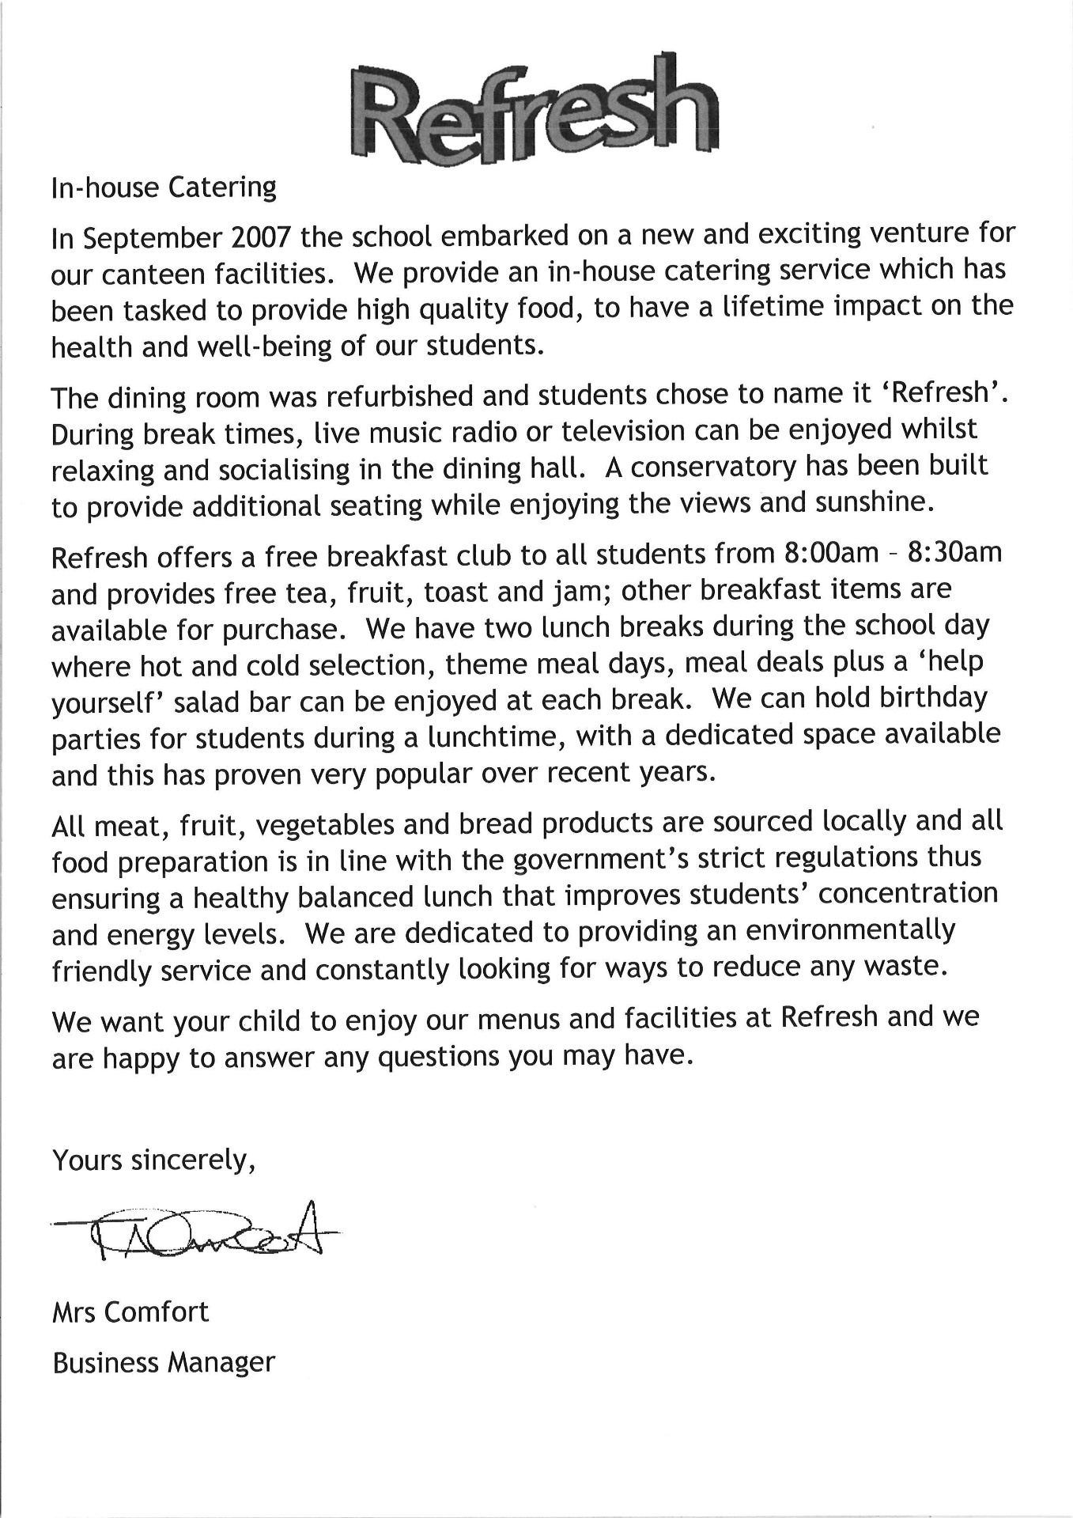



Sample Menu – Indicative of a four week cycle of choice

|  |  |  |  |  |
| --- | --- | --- | --- | --- |
| Cajun Style Chicken or  Homemade Pizza with  Herbed Potatoes | Roast of the Day  or  Vegetable Lasagne  with  House Salad | Beef Meat Balls in Arribiata Sauce  or  Chickpea Balls  In a Mild Spicy Tomato Sauce | Chicken Tikka  or  Halloumi and Vegetable Kebabs in Pitta Bread | Catch of the Day  or  Chicken Pie  or  Tomato and Basil Pasta Bake |
| Grilled Panini | Grilled Panini | Grilled Panini | Grilled Panini | Grilled Panini |
| Pizza Slice | Pizza Slice | Pizza Slice | Pizza Slice | Pizza Slice |
| Pasta Pots | Pasta Pots | Pasta Pots | Pasta Pots | Pasta Pots |
| Daily Specials | Daily Specials | Daily Specials | Daily Specials | Daily Specials |
| Jacket | Jacket | Jacket | Jacket | Jacket |
| Potatoes | Potatoes | Potatoes | Potatoes | Potatoes |
| Or | Or | Or | Or | Or |
| Pasta with | Pasta with | Pasta with | Pasta with | Pasta with |
| choice of | choice of | choice of | choice of | choice of |
| toppings | toppings | toppings | toppings | toppings |
| Salad or | Salad or | Salad or | Salad or | Salad or |
| Vegetables | Vegetables | Vegetables | Vegetables | Vegetables |
| Steamed Sponge  & Custard | Strawberry and Apple Crumble | Chocolate Brownie and Custard | Viennese Biscuits and Custard | Lemon Meringue Pie Cup Cakes |

‘Refresh’ Breakfast Club is available to all students between 8:00am and 8:30am. There are a wide range of additional clubs available to students before, during and after school

Ratton School Timetable

|  |  |
| --- | --- |
| Time | Activity |
| 08.45 | Registration |
| 09.05 | Period 1 |
| 10.05 | Period 2 |
| 11.05 | Break |
| 11.40 | Period 3 |
| 12.40 | Period 4 |
| 13.40 | Lunch |
| 14.15 | Period 5 |
| 15.15 | End of School Day |

Governors

For an up-to-date list of school governors, responsibilities, tenures and photographs please see the Ratton School website at <http://www.ratton.co.uk/governors>

**CYCLING TO SCHOOL AGREEMENT**

Ratton School wishes to encourage children to cycle to school since it improves their health and fitness, reduces traffic outside the school making conditions safer for everyone and benefits their general development.

* The decision as to whether your child is competent to negotiate such hazards on the route from home to school and back must be yours and yours alone. Ratton School does not accept liability for any consequences of that decision.
* It is recommended that parents discuss and agree the safest cycling route with their children, discussing and dealing with any potential hazards.
* There is a limit to the number of cycles we can store safely and securely (120).
* Parents are advised to take out appropriate insurance cover, as the school’s insurance does not cover loss or damage to cycles.

**Cycle Helmets**

All children are advised to wear a correctly fitted cycle helmet and use appropriate reflective clothing and bike lights when visibility is poor.

**Conditions for Cycling to School**

1. All bicycles must be in roadworthy condition
2. Cyclist must ride sensibly and follow the Highway code
3. All bicycles must be locked securely in the approved cycle area

**Student Code of Conduct for ICT**

To ensure that you are fully aware of your responsibilities when using information and communication systems this code of conduct needs to be signed.

* I understand that it is a criminal offence to use a school ICT system for a purpose not permitted by its owner.
* I appreciate that ICT includes a wide range of systems, and not just computers.
* I understand that school ICT systems may not be used for private purposes.
* I understand that my use of school ICT systems, internet and email may be monitored and recorded to ensure policy compliance.
* I will respect system security and I will not disclose any password or security information to anyone other than an authorised system manager, and I will not attempt to gain access to any user account other than my own.
* I will not install or attempt to install any software or hardware.
* I will not damage or attempt to damage any school ICT equipment or software
* I will only use software permitted for student use.
* I will not access or attempt to access any part of a school ICT system that is not intended for students.
* I will not bypass or attempt to bypass the school internet filter to access websites which have not been approved for use in-school.

* I will use ICT in class in a manner appropriate to the lesson being taught.

The school may exercise its right to monitor the use of the school’s information systems and internet access, to intercept e-mail and to delete inappropriate materials where it believes unauthorised use of the school’s information system may be taking place, or the system may be being used for criminal purposes or for storing unauthorised or unlawful text, imagery or sound.

**Useful Addresses:**

The County Education Officer

Children’s Services

P.O. Box 4 County Hall

St. Anne’s Crescent

Lewes

East Sussex

BN7 1SG

Ratton School

Park Avenue

Eastbourne

East Sussex

BN21 2XR

Telephone: 01323 504011

Fax: 01323 520364

e-mail: info@ratton.co.uk

Website: www.ratton.co.uk

Notes