New Student’s
Guide to
Ratton School

2020 - 2021

The Ratton Virtues
Virtue can be understood as the good actions of people. When we live with virtue it builds good character and we become happier and more successful. We at Ratton want to nurture all our students to give them the skills and attitudes they will need throughout their lives. This is why we emphasise 6 virtues that will help students build good character.
We aim to nurture Ratton virtues in all our students so these virtues will be linked to conduct points. Students and parents will receive a record of all the students’ achievement points and sanctions as part of the student’s report.
Compassion
Ratton students show kindness and care for other people and their environment. Students will be rewarded for showing this compassion. This may include showing concern for other people, raising money for our charities or putting rubbish into the recycling bins

Respect
Ratton students act with respect to others both in and out of school. We value diversity and avoid discriminatory language. Students will be rewarded when they speak and act in a respectful way. This may include being polite to others, demonstrating a positive attitude and speaking out when others use discriminatory language.

Creativity
Ratton students are curious about the world around them. They are encouraged to think creatively and ask thoughtful questions. They express themselves articulately and are good problem solvers. Students will be rewarded when they ask good questions or when they express their own ideas well. We will also reward those who can find solutions to problems and
work independently.

Teamwork
Ratton students know the importance of working as part of a team. They understand that we all have to do our fair share and get along with different people. Students will be rewarded when they demonstrate that they can work hard to ensure team success. We will also reward those who participate in teams in extracurricular activities such as music, dance, sport or enterprise projects.

Effort
Ratton students know that to be successful takes effort and resilience. Students are expected to put effort into all their endeavours, whether it is class work, homework or extra curricula commitments. Students will be rewarded when they put effort into lessons; especially when they show resilience and keep trying even when the task is a challenge.

Responsibility
Ratton students act responsibly by making sure that they are in the right place, at the right time, doing the right thing. They take responsibility for ensuring they have the right equipment, complete homework to a good standard and have a good attitude every lesson. Students will be rewarded for consistently demonstrating that they are ready to learn.

Tutor Group ……………………………….… Room No. …………………………………………
Community …………………………………………………………………………………………………
Tutor …………………………………………………………………………………………………
Head of Community …………………………………………………………………………………………………
Assistant Head of Community …………………………………………….…………………………………

s

I need to find out from my Tutor:
- Where to go and what to do if there is a fire drill
- Where I can and cannot go at break and lunch times
- What happens when it is a wet break or lunch time
- What day I have assembly
- What happens if I am late to assembly
……………………………………………………………………................. ..………………………………………………………………….................. ……………………………………………………………………................. ………………………………………………………………….................... …………………………………………………………………....................

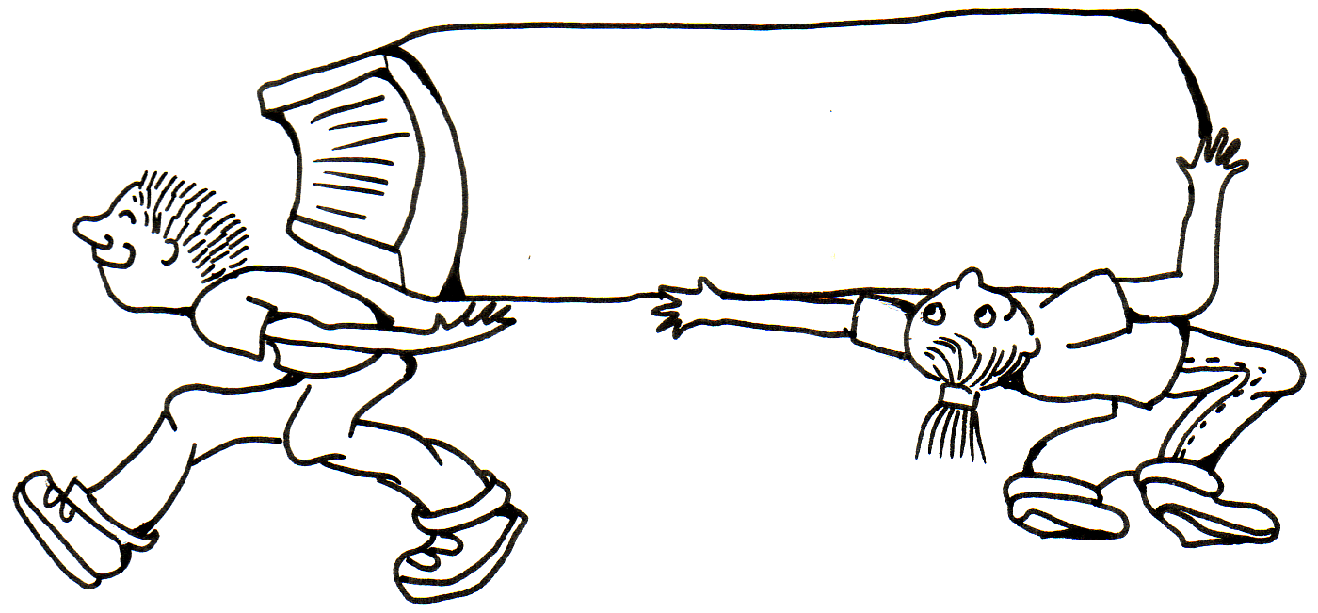

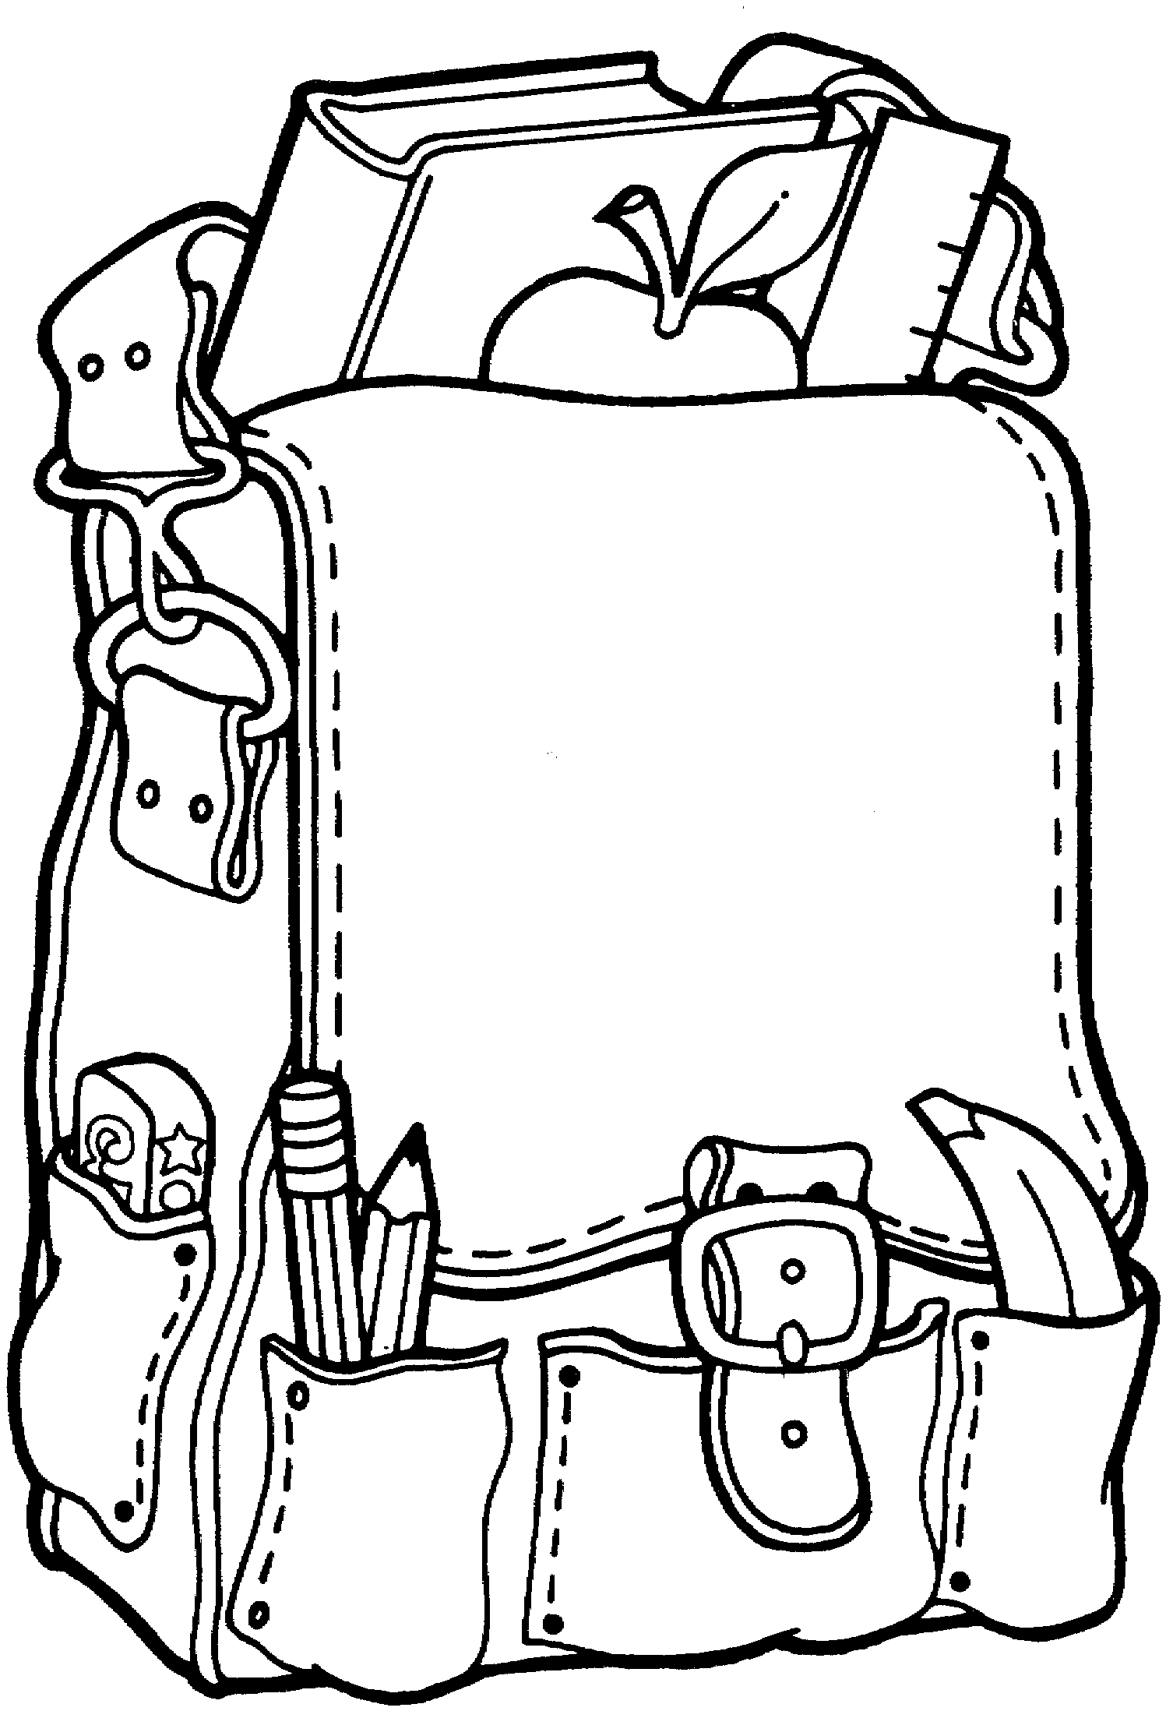
Where do I go if...
I need a password to use computers in School?
You will be allocated a password which you can use to log on to any computer in the School. Speak to your form tutor for more information.

I feel unwell?
If it is during lesson time, explain to your teacher what is wrong and they will advise you what to do. If it is outside lesson time, inform a member of staff who will advise you what to do.

I am worried about something?

Go to your tutor as they will get to know you best. They will listen to you and advise you what to do. If you would rather talk to another student, speak to a Peer Supporter. Photographs of these students are on display next to the Welfare Office.

If I feel I am being bullied?
Talk to your tutor, a member of Care and Welfare, the anonymous Text 4 Help line or speak to a Peer Supporter if you would rather talk to another student. You must tell somebody so that something can be done to stop it.

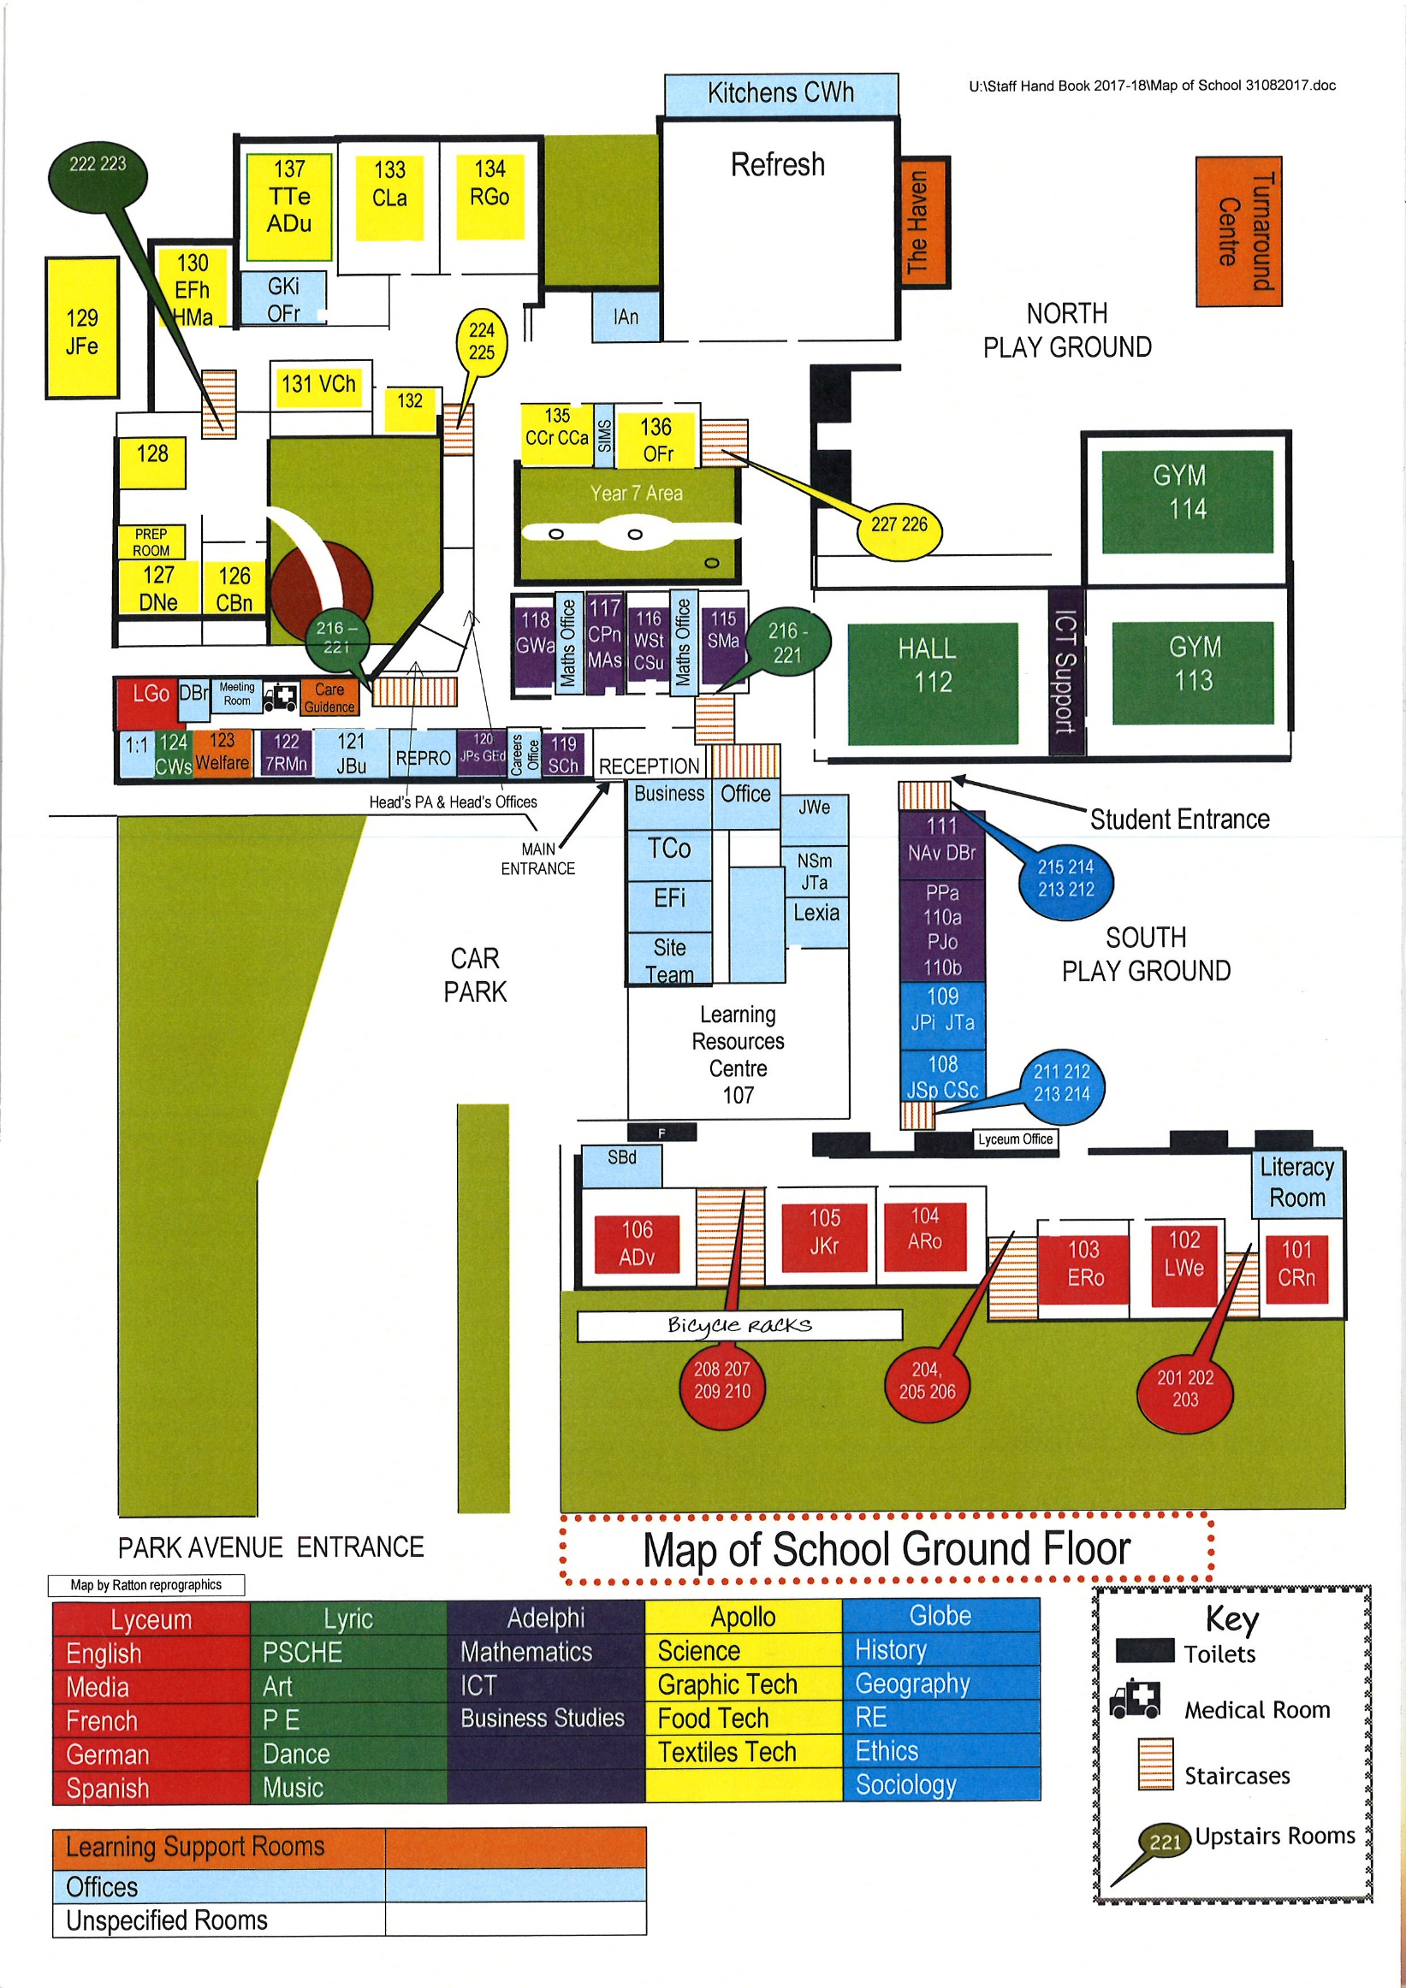
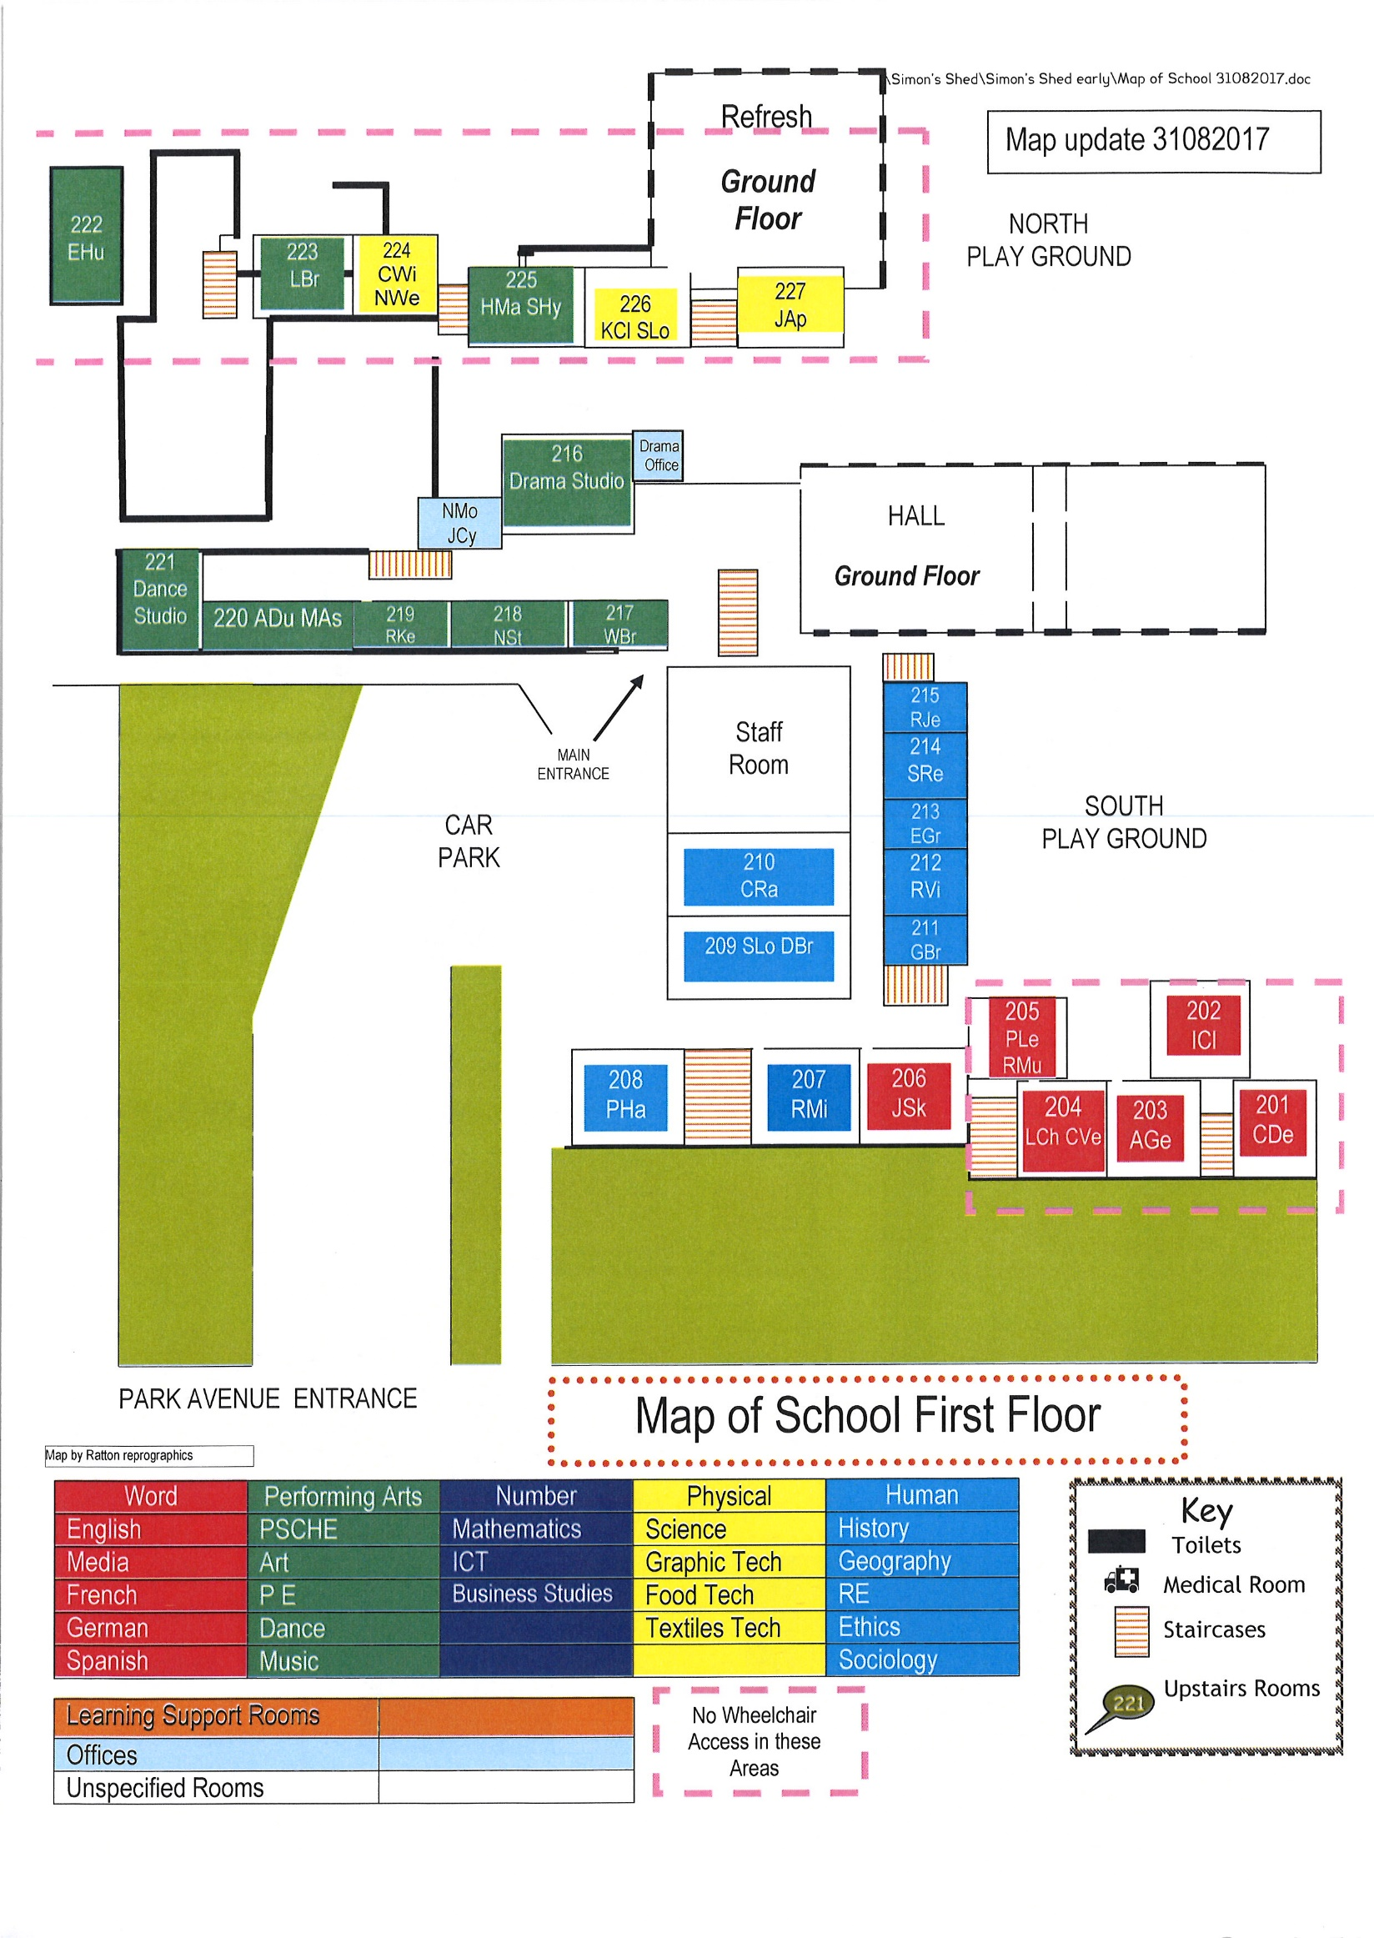
Expectations of Ratton Students
Assemblies
Community assemblies take place once a week. Make sure you know when yours is and go straight to the hall at 8.40 am where your tutor will register you. Remember to put your coat in your locker before assembly. Enter the hall and sit down quietly in your community. Your tutor will tell you where to sit. There are also smaller assemblies that take place in the Drama Studio, sometimes in year groups and sometimes in communities. Your form tutor will tell you about these. Remember to wear your sweatshirt.
In the Classroom
Line up quietly outside the room until your teacher allows you into the room. Sit in your place in the seating plan. Put your student diary, pencil case (PPRD), wipeboard pen and exercise book on the table in front of you so that you are ready to learn. Remember, you are not allowed to eat or chew gum in any classroom but you may have a bottle of water on the table if you are allowed.
Outside the Classroom
We expect students to walk (never run) around quietly and keep to the left in the corridors. We also expect all students and staff to show respect and consideration for one another at all times.
Tutor Time
You will have one formal registration period during the day along with a registration in each lesson. The formal registration will take place from 8:45am in the morning before lessons. There will be planned tutor group activities, such as group discussions, individual or small group chats, using diaries to check homework, checking you have your diary and equipment or silent reading. This is also a chance to talk to your tutor about how you are getting on and about anything that is worrying you. Your tutor will sometimes give you notices about things going on, or give you letters to take home. Tutor time is a very important time and, just as with lessons, you must arrive on time. If you are late to tutor time, you will receive a Basics detention.
Literacy
Ratton School takes part in ‘Drop Everything And Read (DEAR)’ regularly where staff and students stop all activities to read for pleasure. The times and periods affected change on a termly basis. Students will also take part in a reading programme appropriate to their level of literacy.
Homework
This will be set regularly and must be recorded in your diary each day. It is published in advance for each term on the website for years 7 - 9. If you have any problems completing your homework, make sure you see your teacher before it is due.

Uniform

- Ratton School Black Trousers (for boys and girls, available only from Ratton School)
- Ratton School White Polo Shirt
- Ratton School Sweatshirt (which must be worn for all formal occasions, e.g. assembly)
- Black School Shoes (without any markings)
- PE uniform obtained from school

Please note that coloured t-shirts, cardigans and fashion jewellery, unnatural hair colours and excessive make up are NOT allowed.
Rewards
These can be given for many reasons but mainly for good class work or homework. Your subject teachers may also send a postcard or letter home for continued good work in their subject.
Sometimes you will be given rewards for taking part in an activity outside lesson time. Remember to write down all the rewards you get in your homework diary. We celebrate achievement throughout the year and at a special event at the Winter Garden.

Ratton School Timetable
Time | Activity
08.45 | Registration
09.05 | Period 1
10.05 | Period 2
11.05 | Break
11.40 | Period 3
12.40 | Period 4
13.40 | Lunch
14.15 | Period 5
15.15 | End of School Day

Getting to know you
Write down the names of others in your tutor group who?
Is a  vegetarian | Was born  abroad | Has been  on television | Speaks more than  one language
Does not live in Eastbourne | Knows the offside rule in football | Has never been to London | Plays a musical instrument
Has a female cousin | Can whistle by putting their fingers in their mouths | Has been swimming in the sea during the summer holidays | Has never been camping
Has been to America | Can count to ten in French | Hates sprouts | Has blue eyes

Bacon sandwich £1.00

Free fruit

