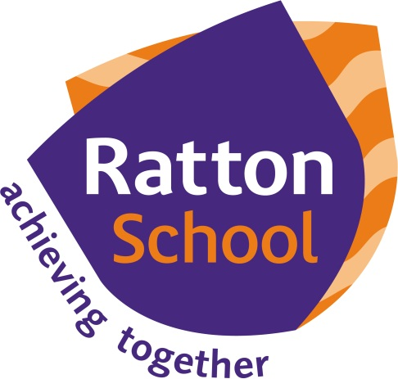

Home
School Agreement

2020 – 2021

A copy of this document can be found electronically at:

http://www.ratton.co.uk/starting-ratton

Home school Agreement – Student
I will have:
Compassion | To everyone I meet
Respect | For myself, those around me and the environment I inhabit
Creativity | To produce excellent work
Teamwork | To work well in a group and let others take a turn
Effort | To put 100% into all aspects of my school life
Responsibility | For my actions and take accountability in situations

Home school Agreement – School
We will have:
Compassion | To encourage your child to believe in themselves and make sure that they are coping with school life
Respect | For your child’s views and opinions, their learning and Ratton School facilities
Creativity | To get the best out of your child and to help them make the best progress in different ways than they may be unaccustomed to
Teamwork | To get your child to work with other students and communicate their ideas and listen to others’ viewpoints
Effort | To let your child to work freely whilst also making sure they are performing at their best
Responsibility | To ensure your child is safe on the premises, and out of school; by contacting parents at an early stage should any problems arise; by regularly informing you about general school matters and your child’s progress in particular

Home school Agreement – Family
We will have:
Compassion | For my child and their school, and teach them to show empathy
Respect | For my child; their learning and Ratton School
Creativity | To let my child’s imagination flourish and for him or her to enjoy their learning
Teamwork | To develop my child’s ability to work well in a group and have a positive impact on other people
Effort | To teach my child to be fully determined in everything they do
Responsibility | To teach my child to be accountable for their actions and views
The Home School Agreement has been produced by the Ratton School Student Parliament in conjunction with school staff. This document sets out the expectations of all stakeholders; student, school and family in accordance with the school’s virtues.
Ratton School also actively promotes the British Values of democracy, the rule of law, individual liberty, and mutual respect and tolerance of those with different faiths and beliefs.

