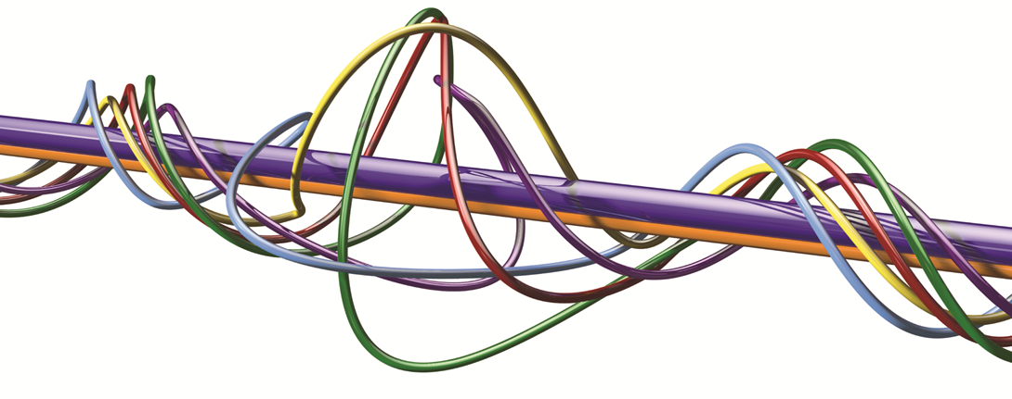
School-based Professional Studies Programme
TERM 1
NQTs and ITT 2016-2017
Tuesdays in Room 218, 3.30pm to 4.30pm

Week | Topic | Provider | Standards
Term 1
27th September | What to expect and Welcome  Identifying Training Needs Audit | NSt | 8
4th October | Heads Greeting | HKn
 | Workshop: Voice and Presence in the Classroom  - How the voice is created  - Using your voice as a tool not a weapon!  - Managing the space you work in | NSt  Professional Tutor | 7
11th October | Working with SIMs  Getting Started  Exploring Data | ADa
18th October | Behaviour Management  Dealing with low level issues | Ple

